Fusion Photobooth Guide

1. Hardware setup

Hardware requirements
- (2 Desktops and 2 Monitor / 1 Desktop, 1 Monitor and 1 Laptop with LAN Port)
Recommended minimum specifications for photobooth: 8 core CPU, RTX 3080 equivalent GPU, 32GB RAM, 1 Gigabit Ethernet, 50 GB+ of disk space)
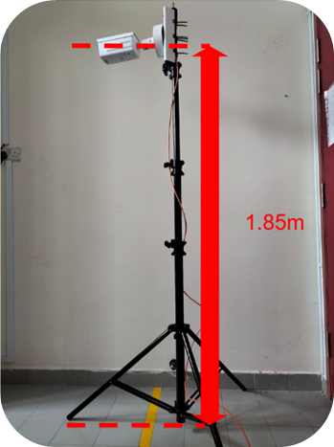
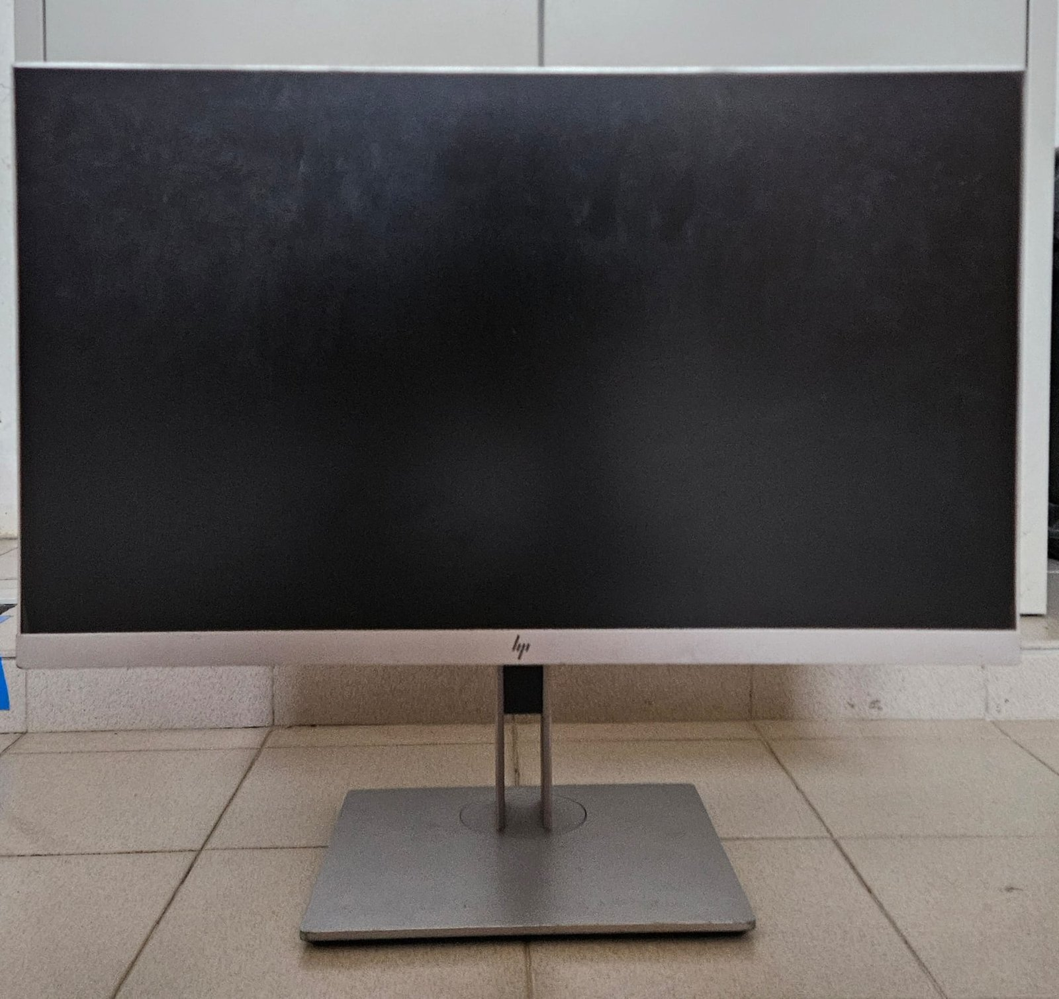
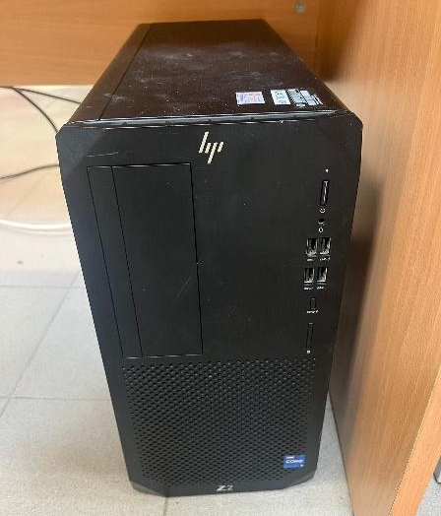
- HIKVISION IP camera (iDS-2CD7A46G0-IZHS, or any RTSP camera).
The ideal height and angle for the placement of the camera is 1.85M and 90° respectively.
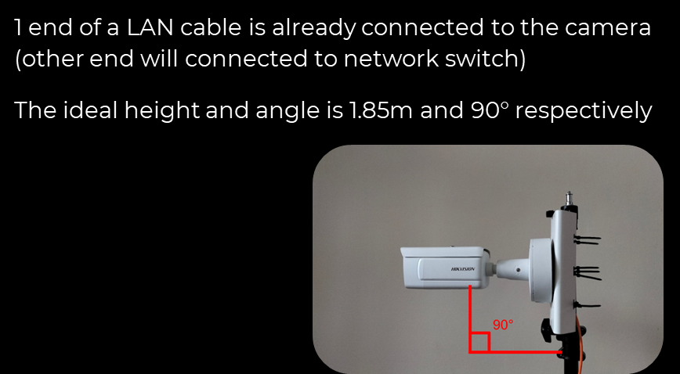
- Or alternatively DSLR Camera on a camera stand (can be loaned from HQ)
The ideal height and angle for the placement of the camera is 1.85M and 90° respectively.
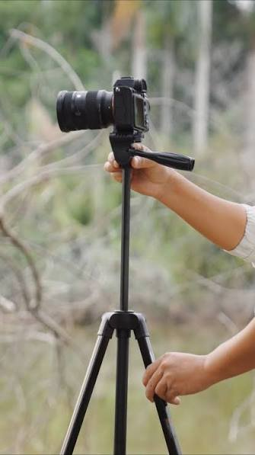
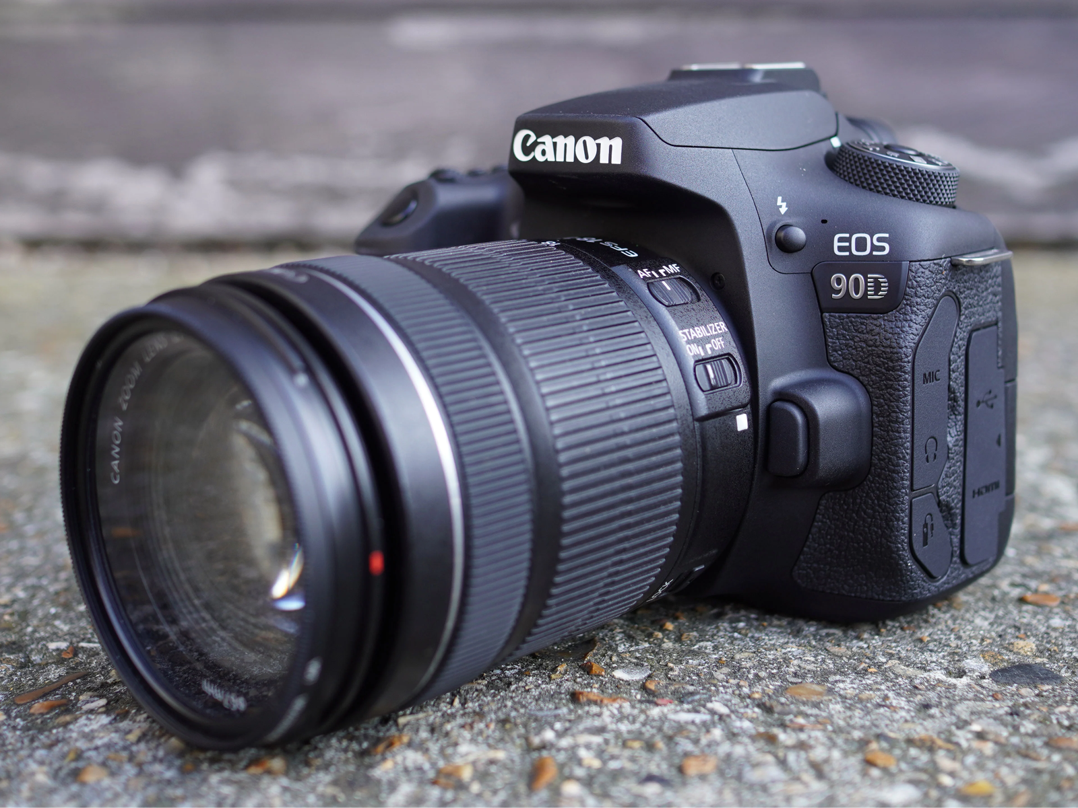
- Any network switch with Power-Over-Ethernet (POE). If the gallery will run on the second PC, both PCs must be connected to this switch. (more explanation later)
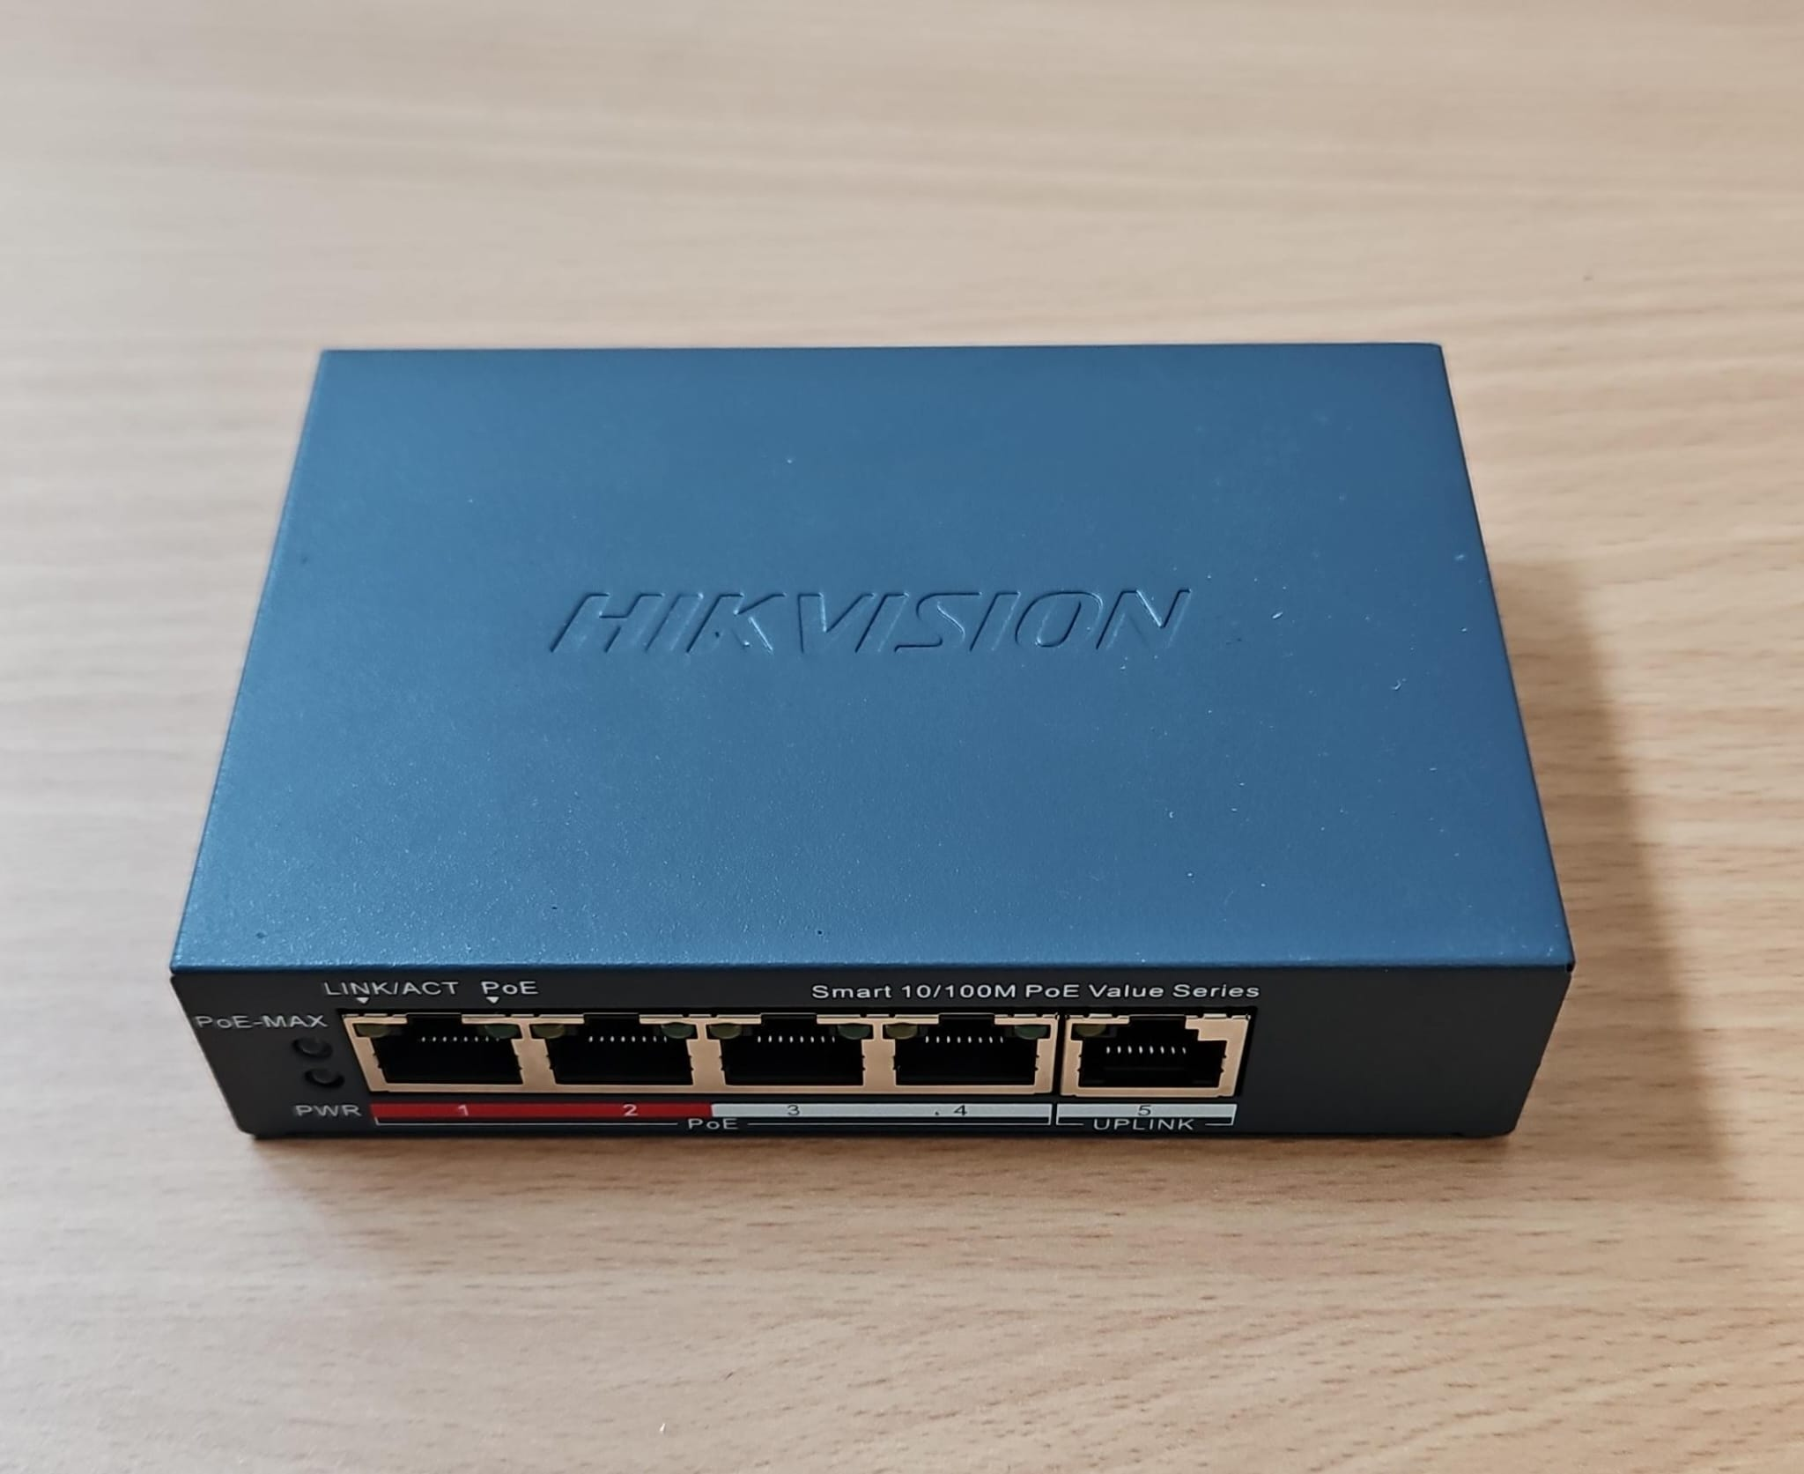

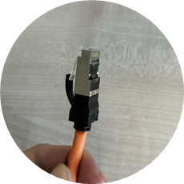
- Sufficient CAT 5 (or faster) LAN cables.

- Sufficient Power Cables, SoapBars, Power Drum
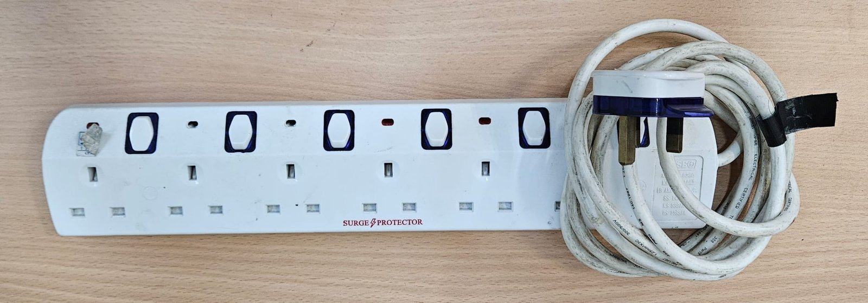
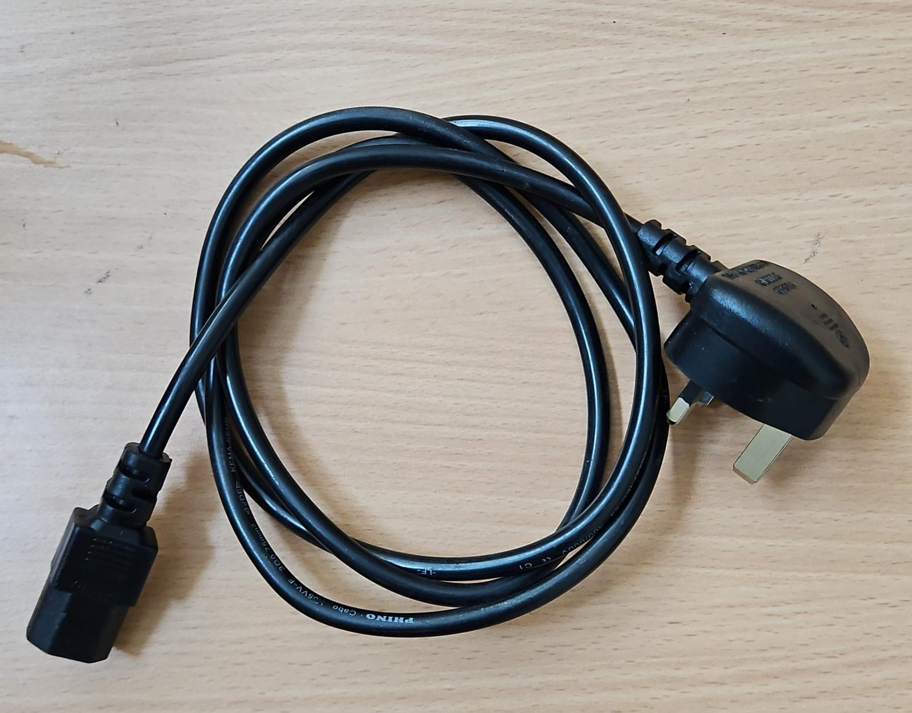
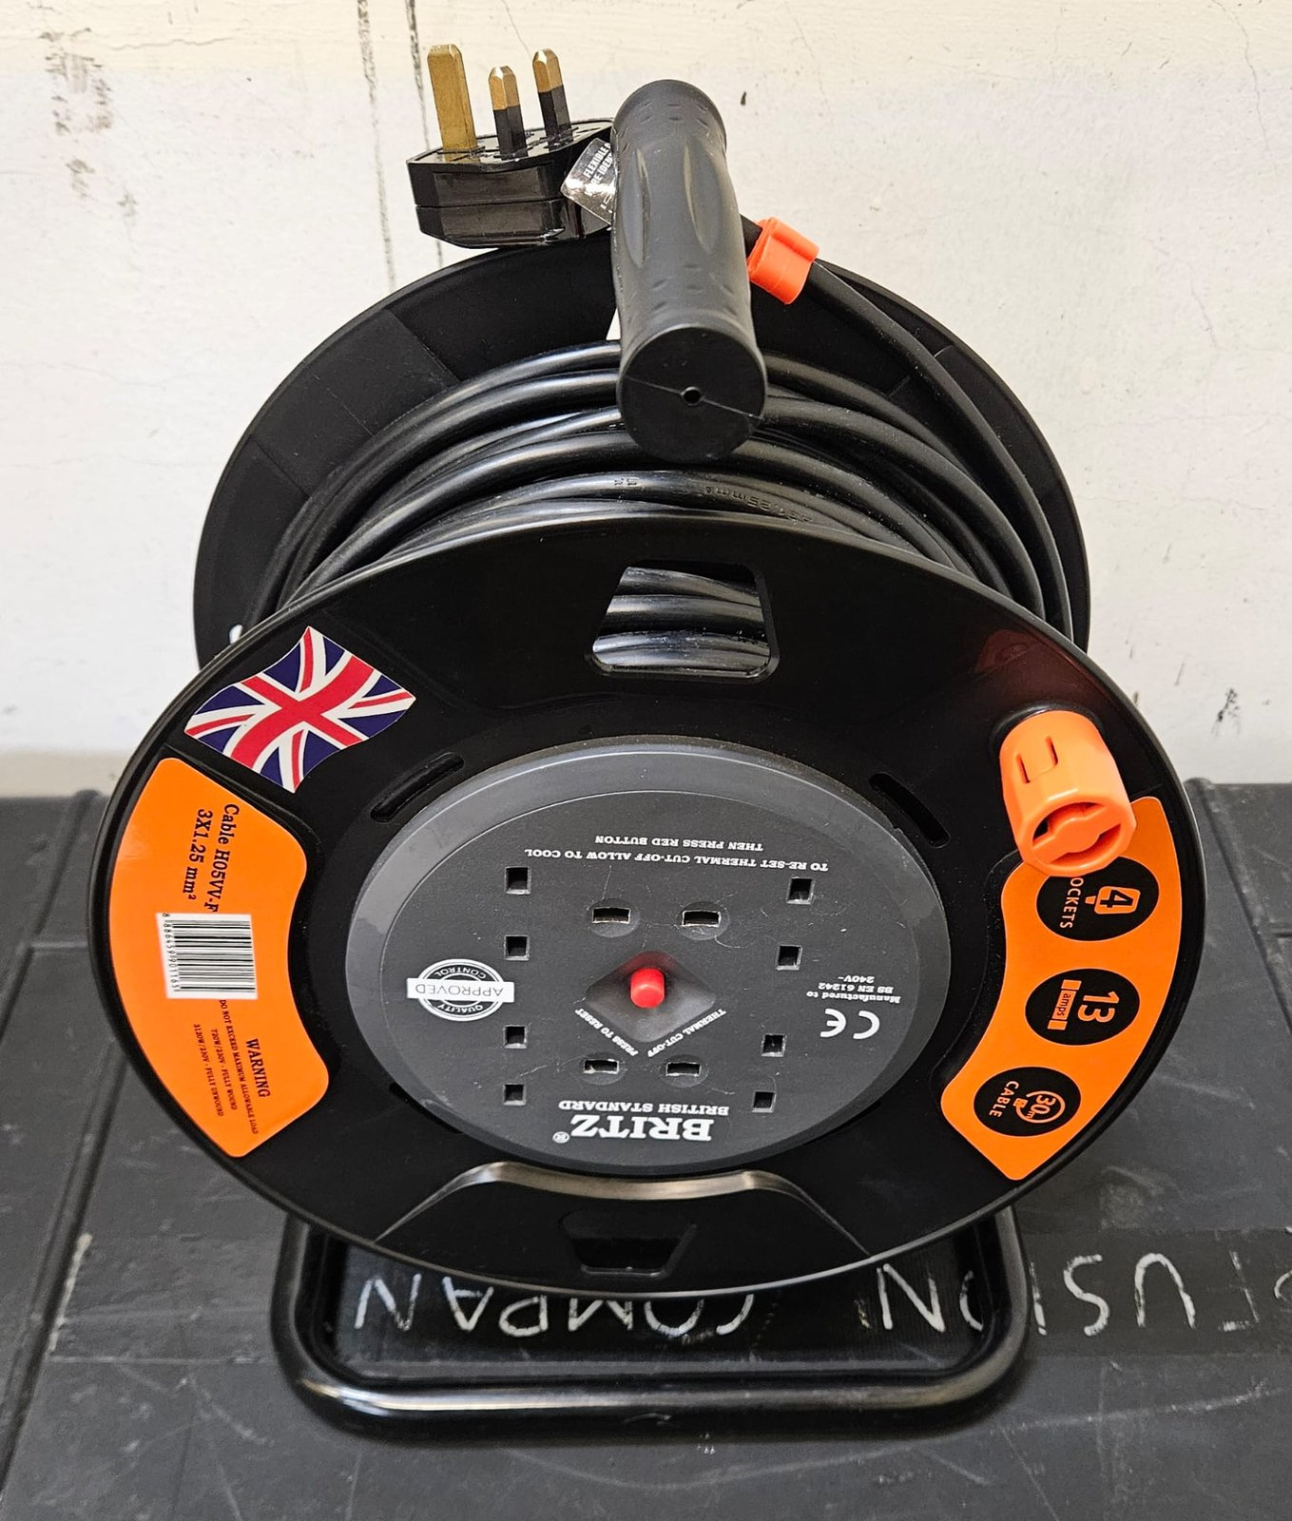

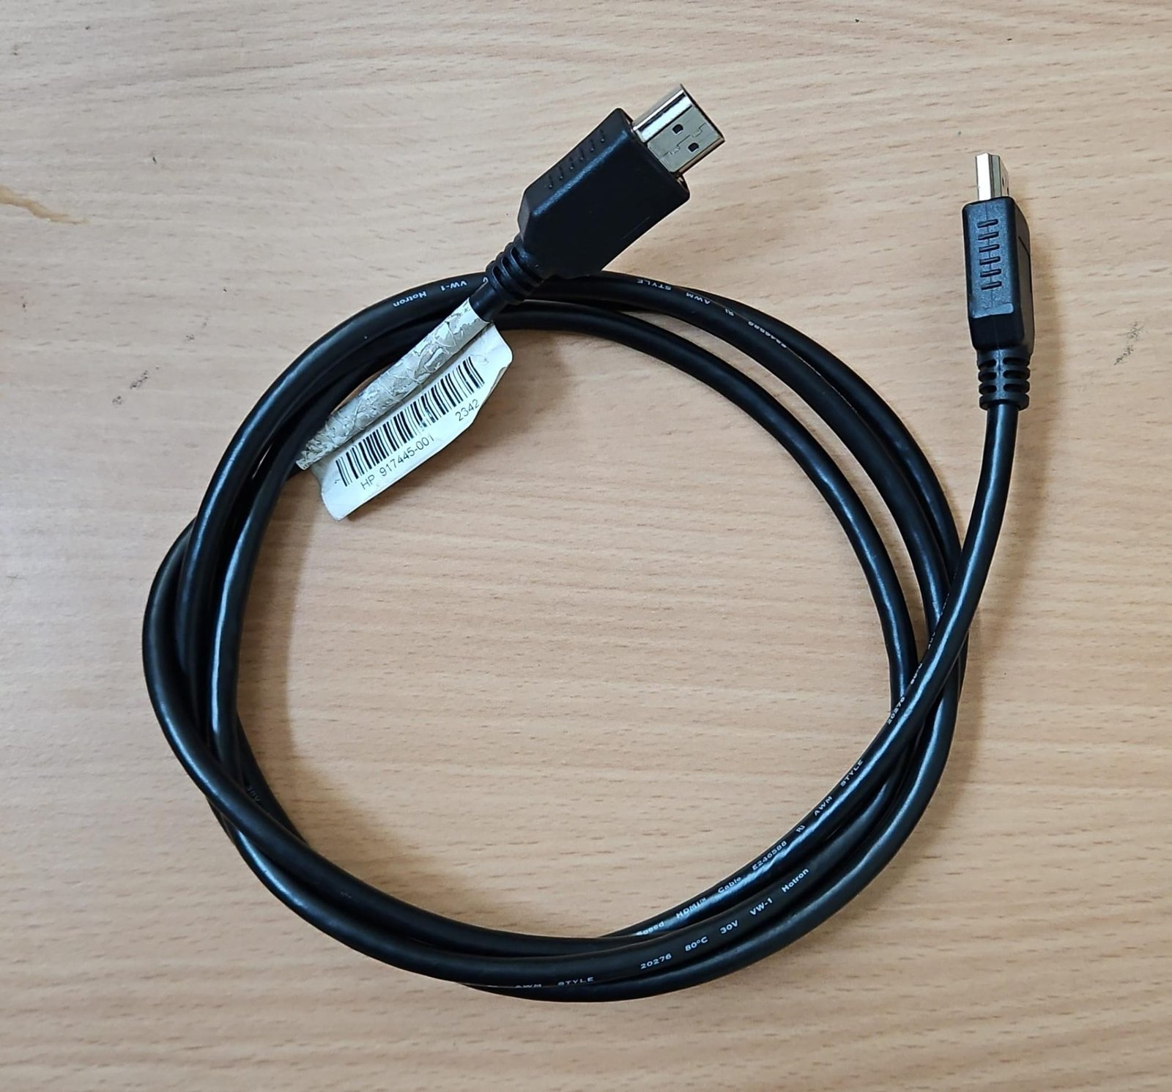
- Sufficient HDMI/DP Cables (Do note that each malibu has 1 HDMI & 4 DP ports)

- Sufficient Keyboard(s) and Mouse(s)
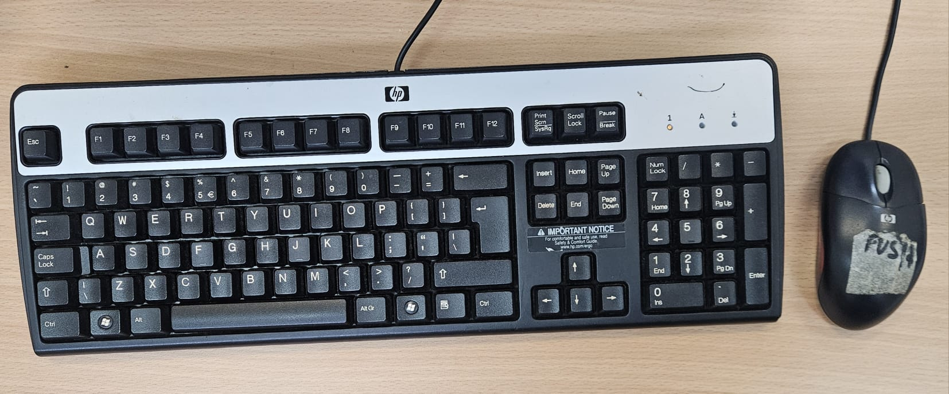

Basic Setup (Photobooth)
This setup is the full setup for future events that require the photobooth.
- Setting up the Desktop and Monitor
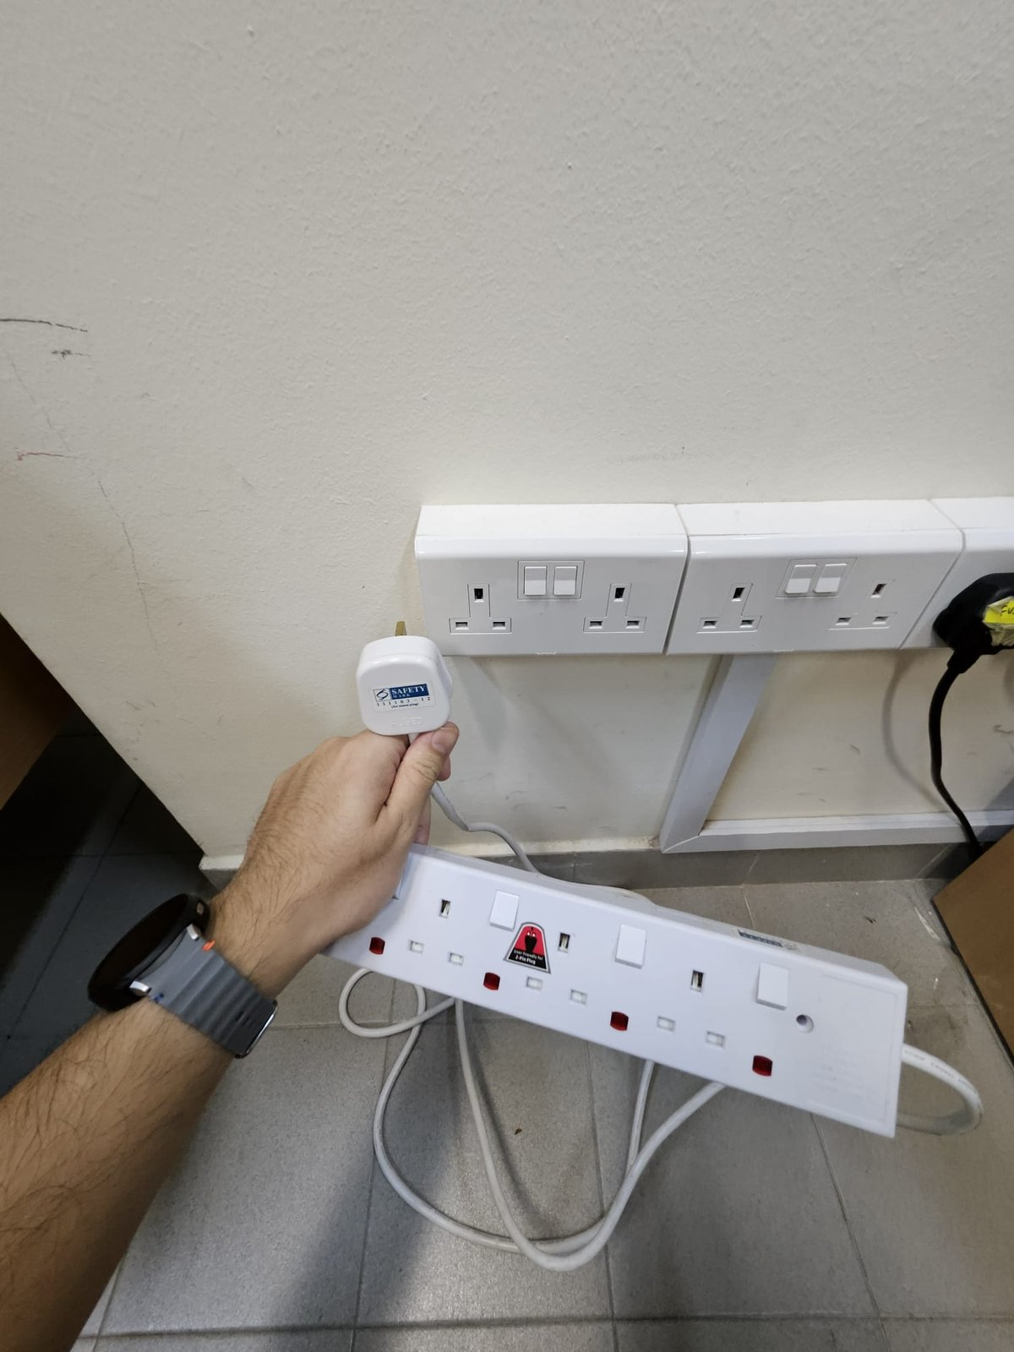
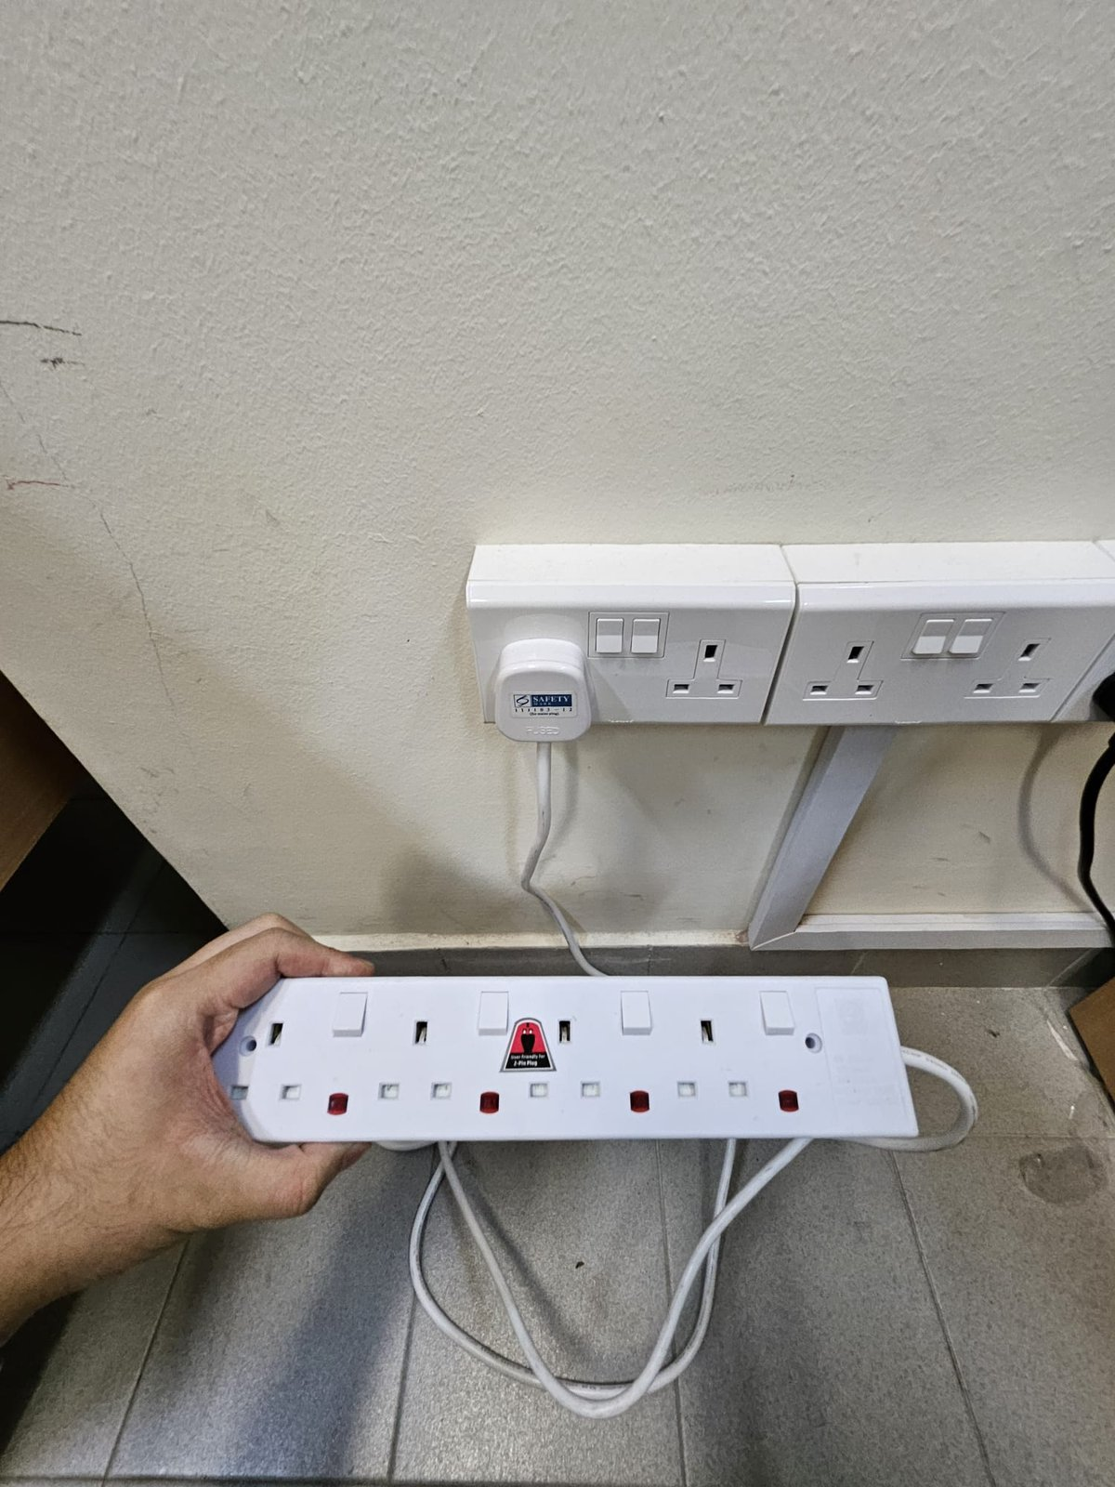
- Plug the Soapbar into a socket.
- Plug the power cable into the Malibu(Back of the Malibu)
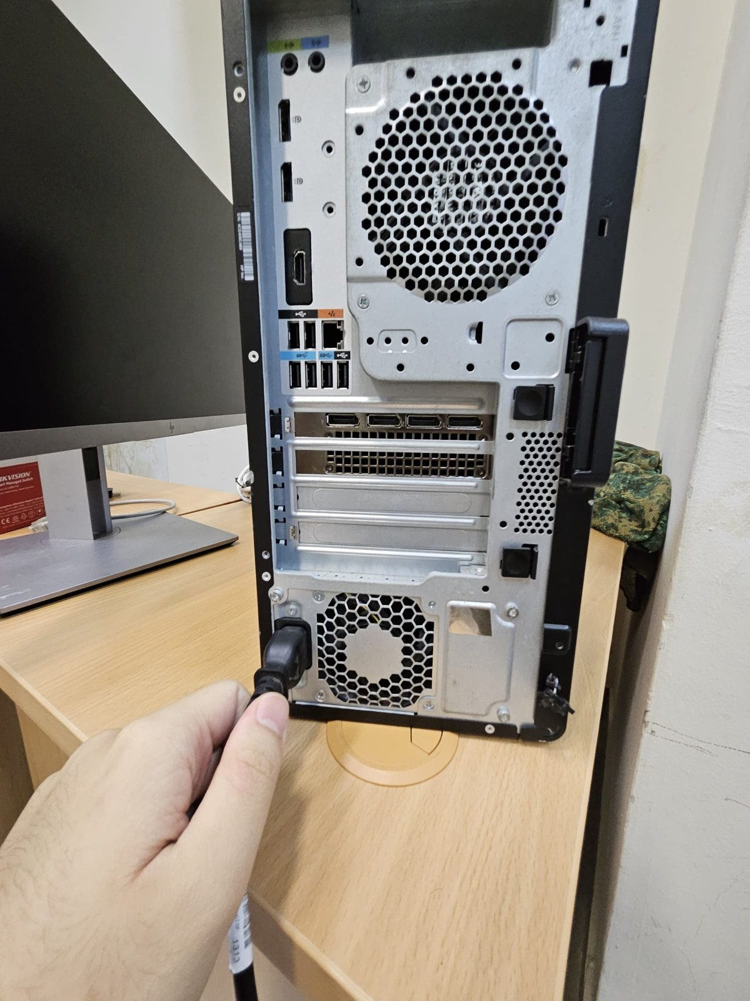
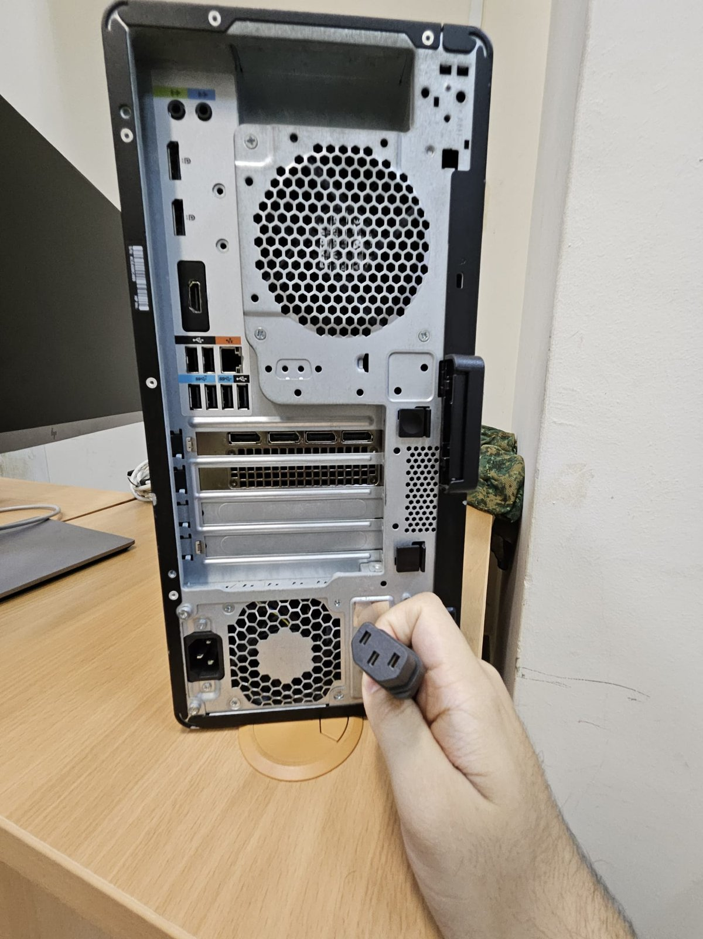
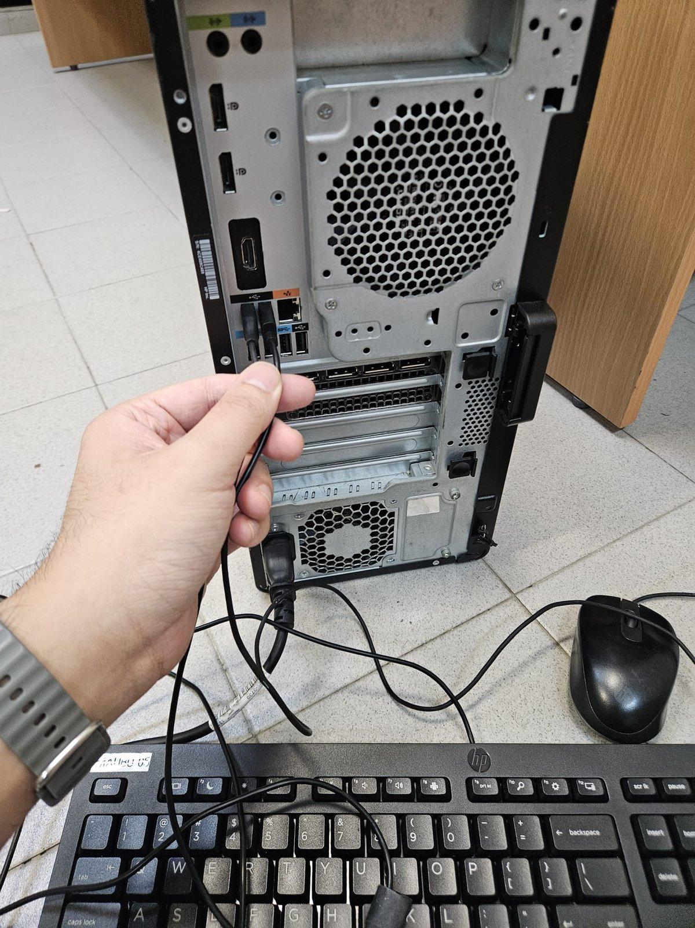
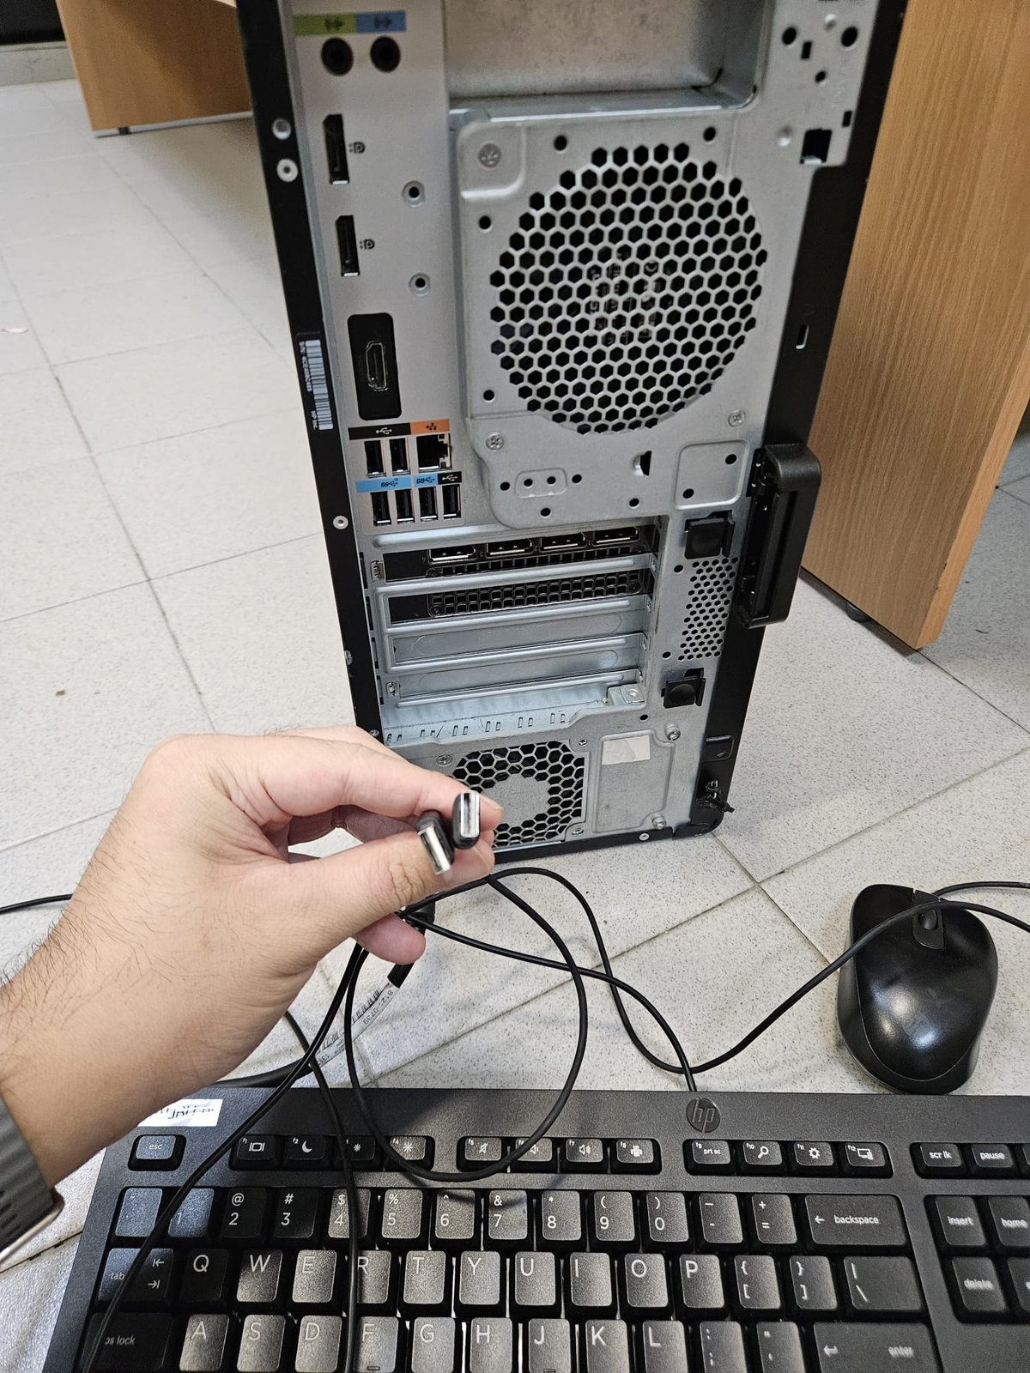
- Plug the keyboard and mouse into the Malibu.
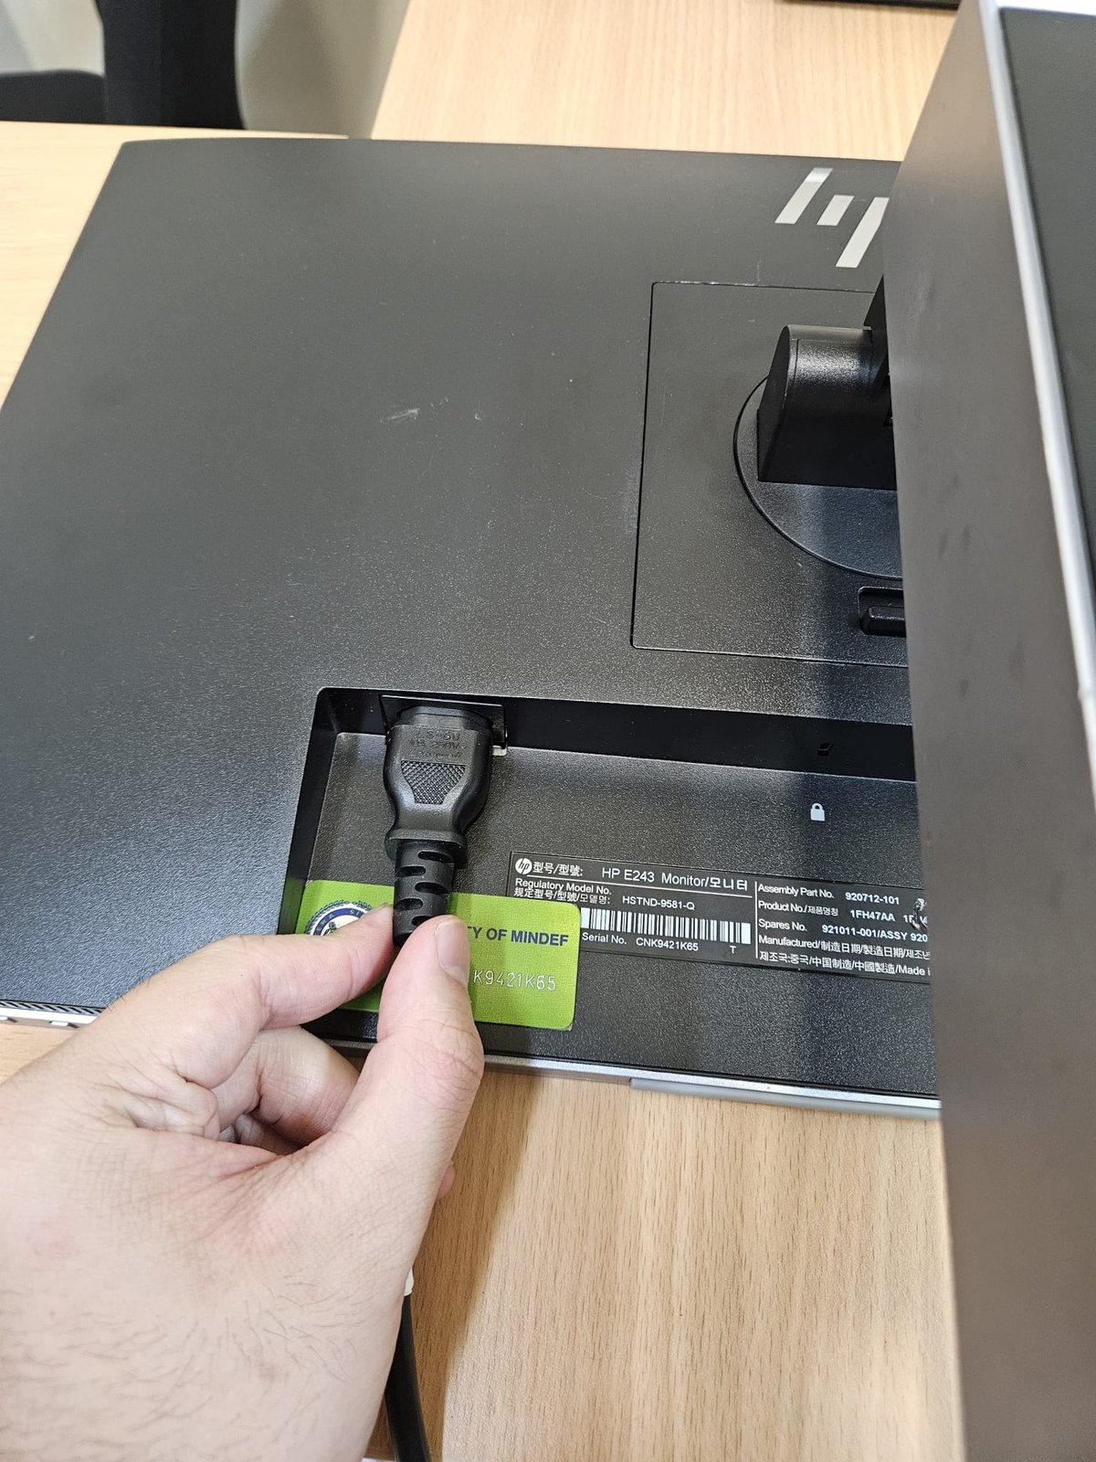
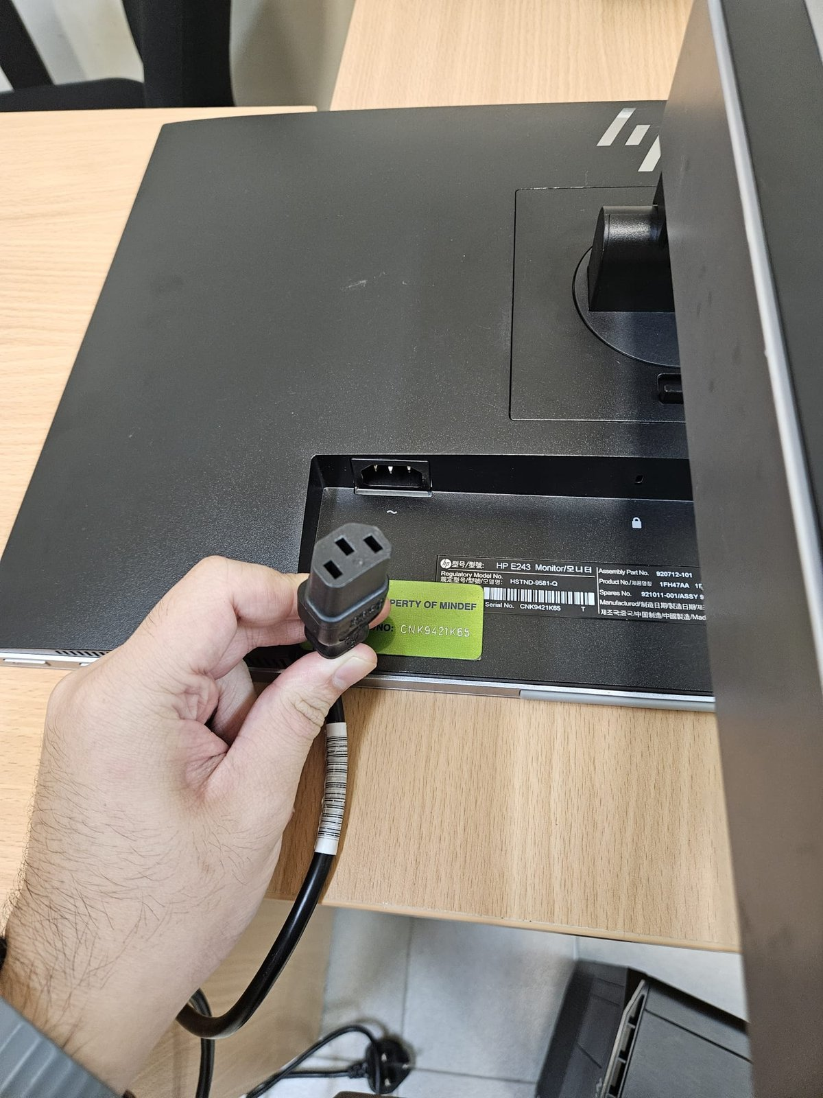
- Plug a 2nd power cable into the monitor

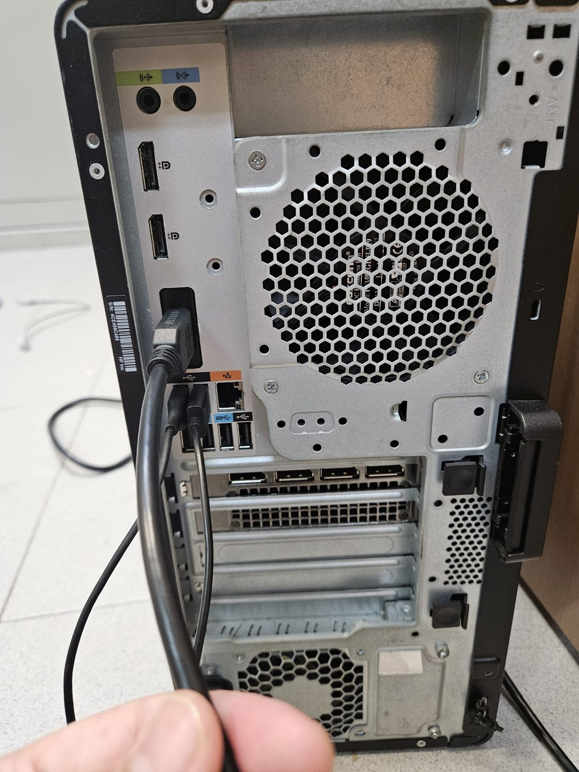
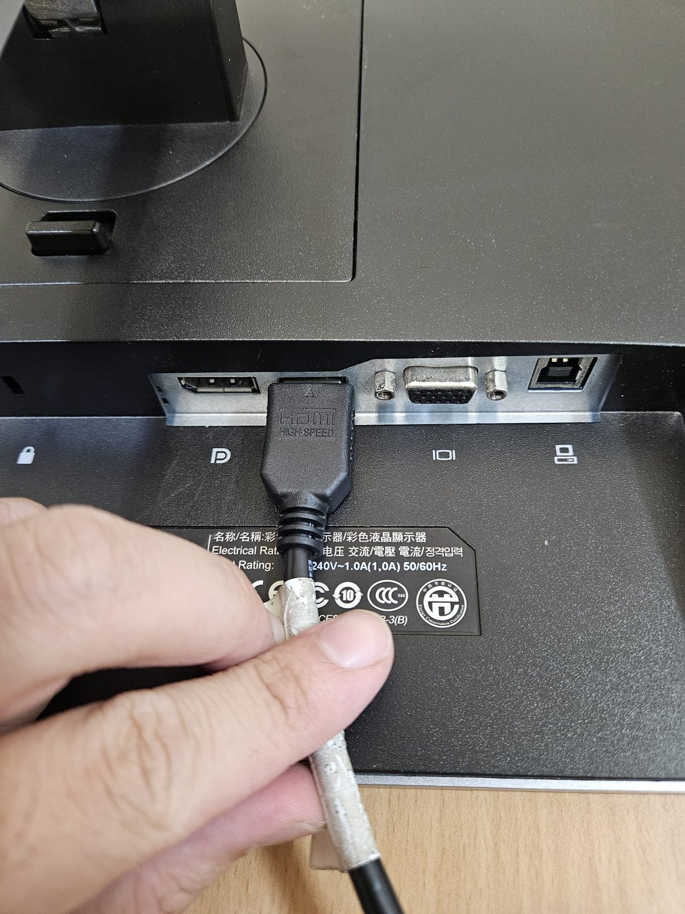
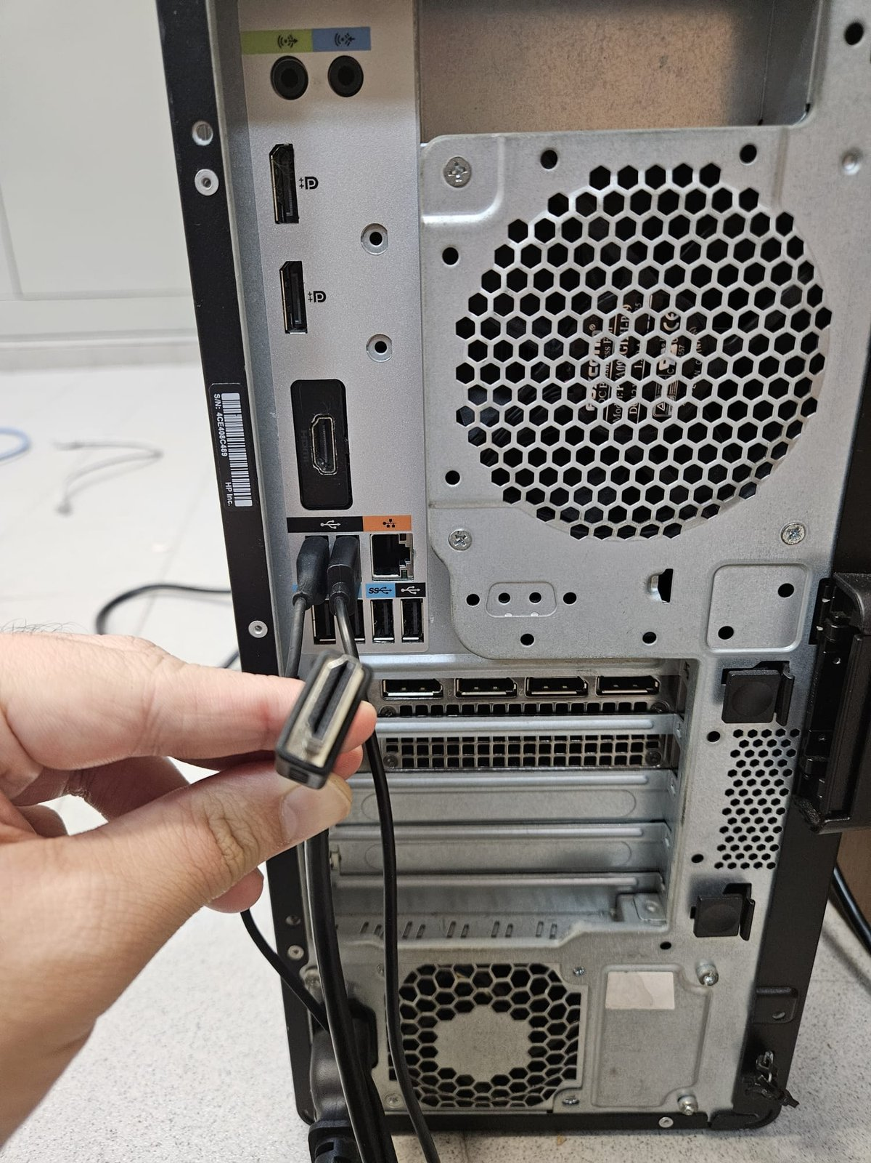
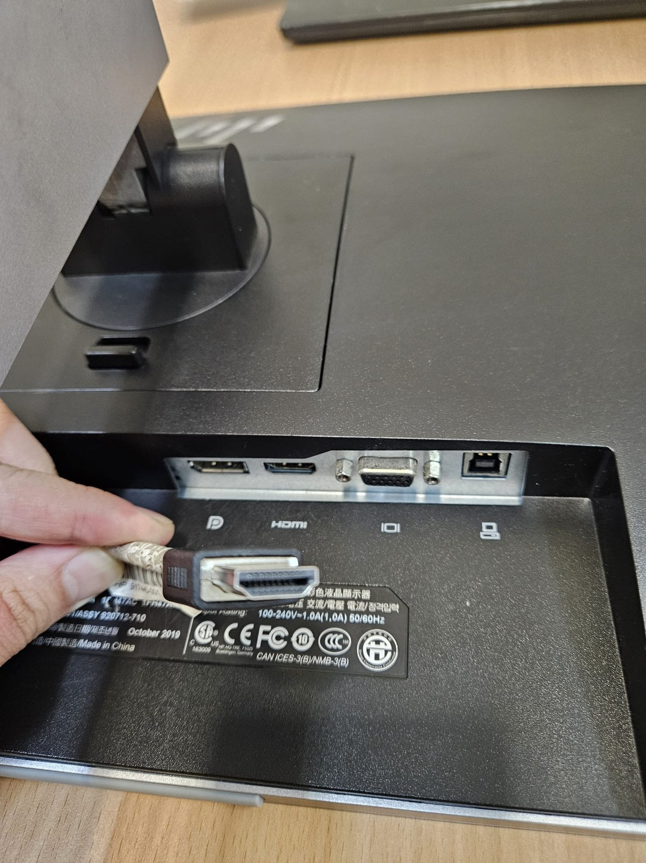
- Plug either a HDMI or a DP cable into both the Malibu and the Monitor

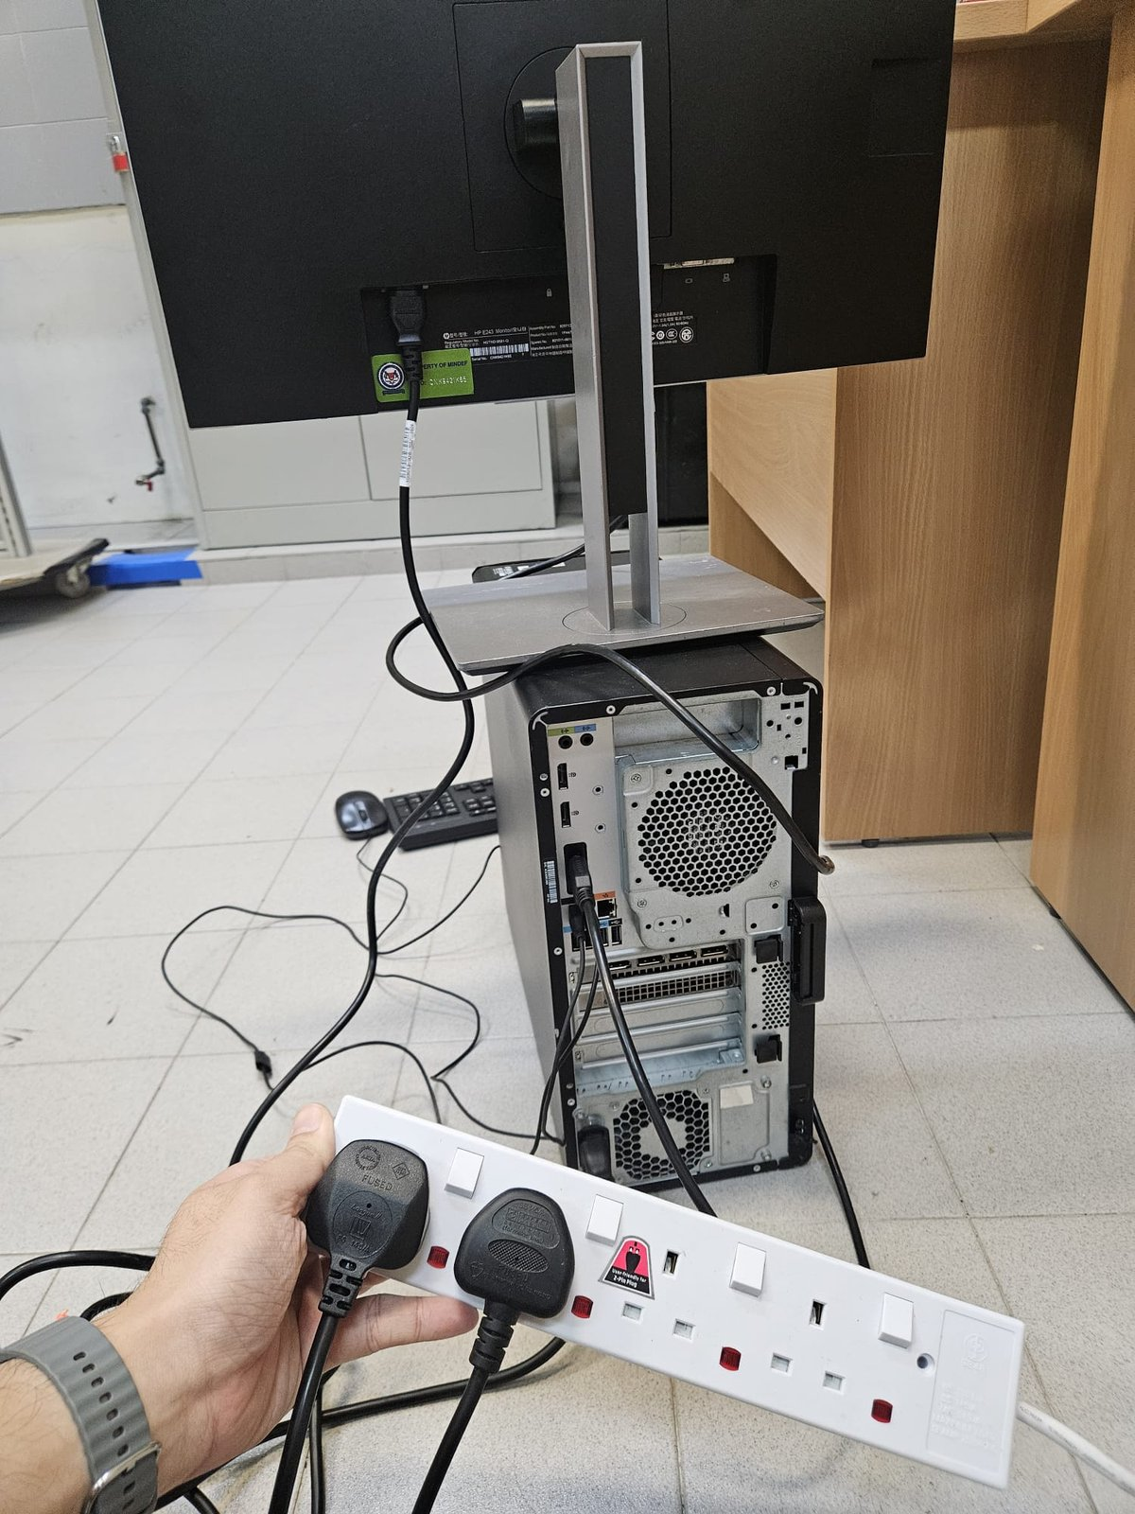
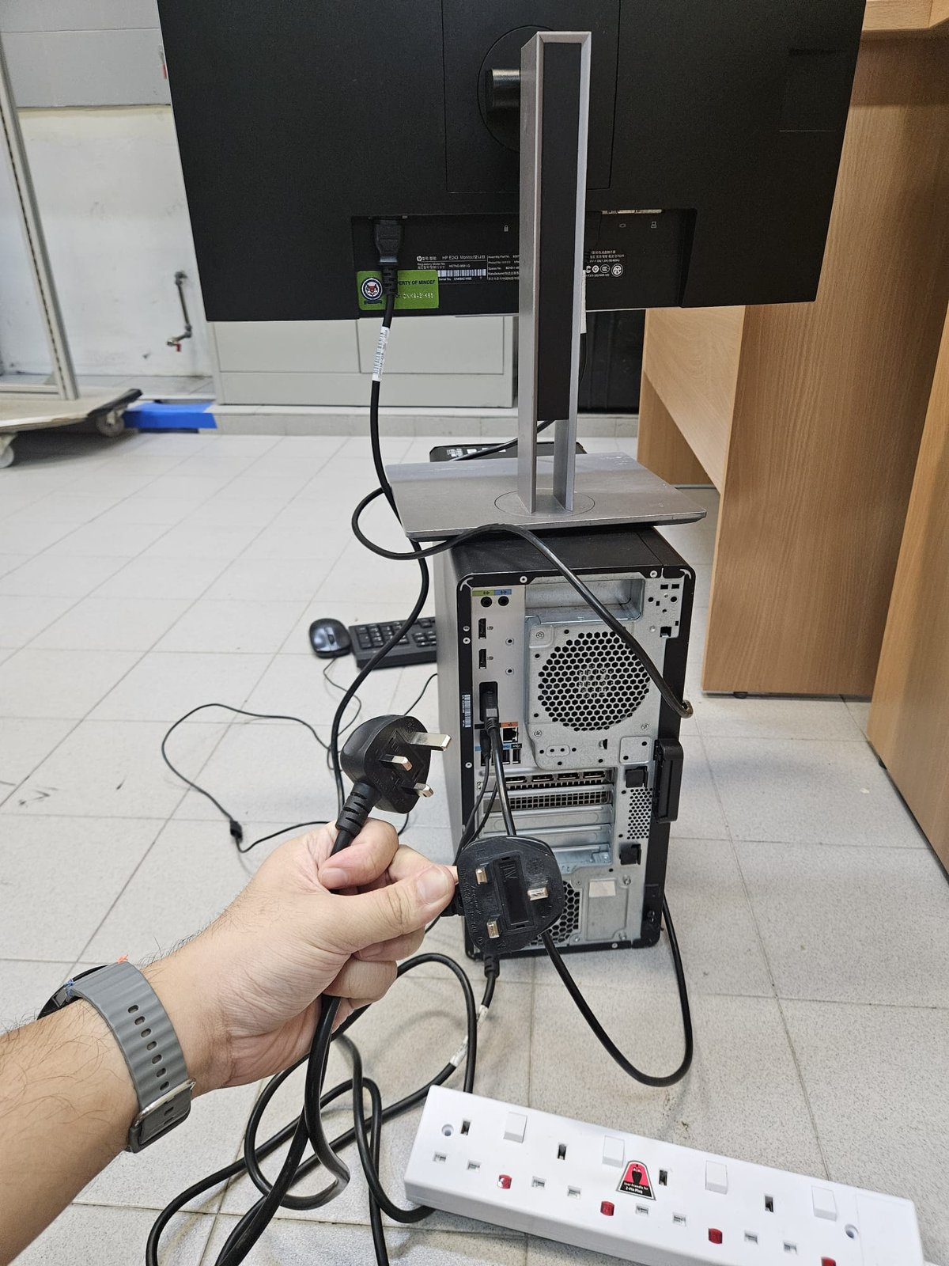
- Plug both the power cable from the Malibu and Monitor into the Soapbar.

- Flip the power switch on the socket and the soapbar to on.
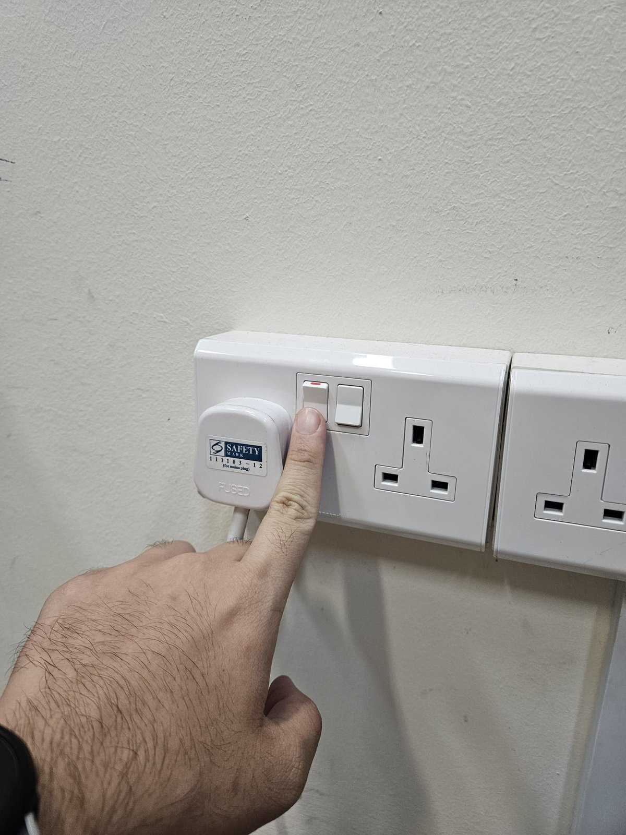
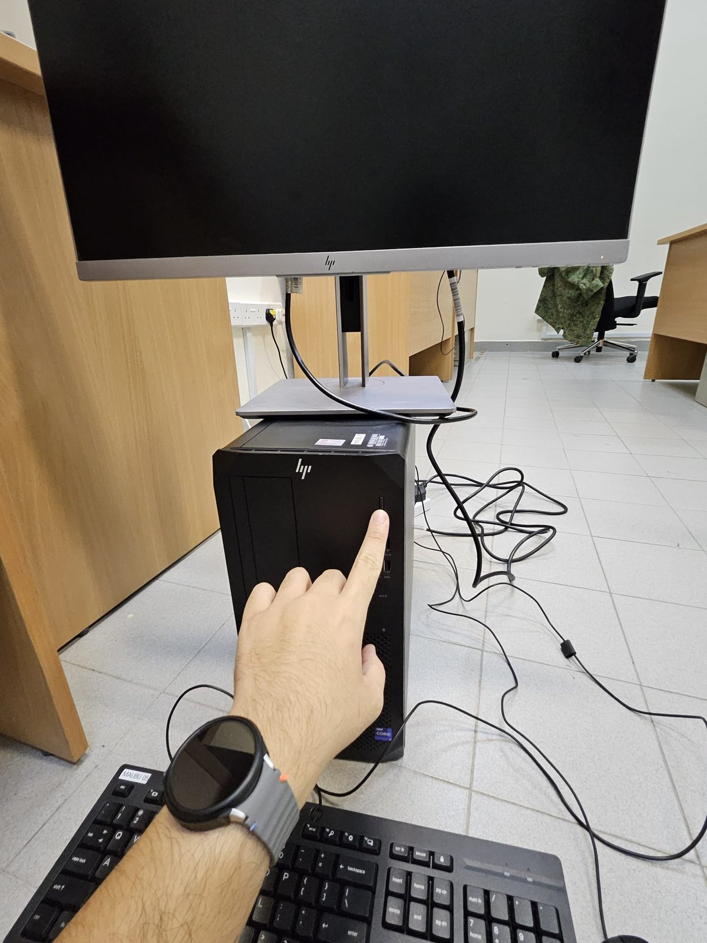
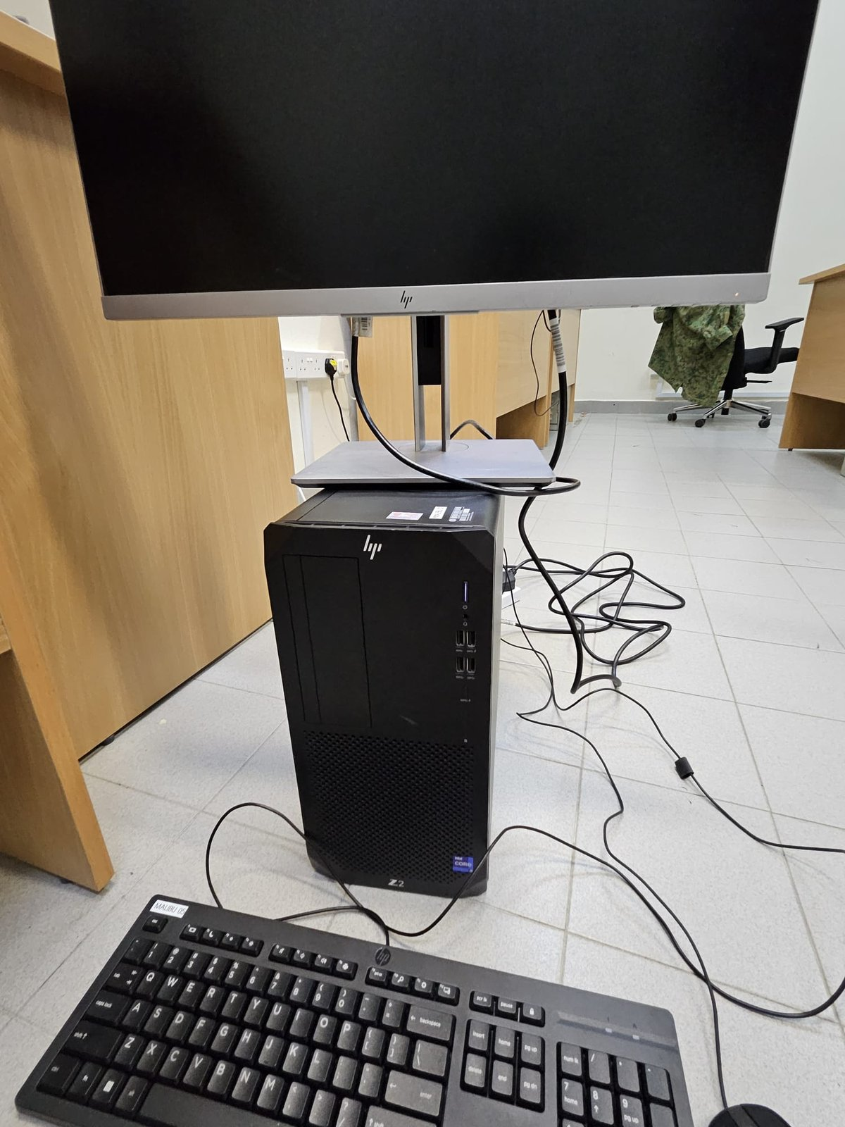
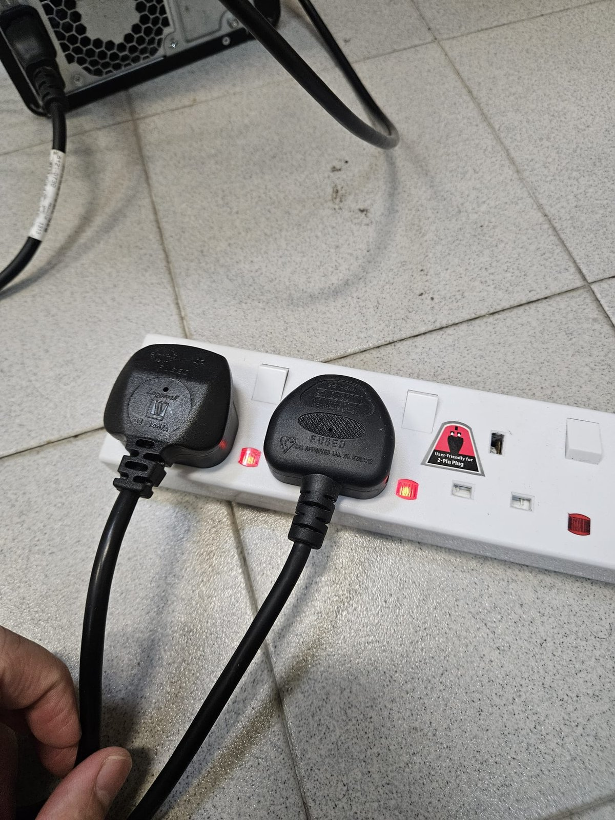
- Turn on the Malibu
- Login to the Admin account(Password is in the Family Chat).
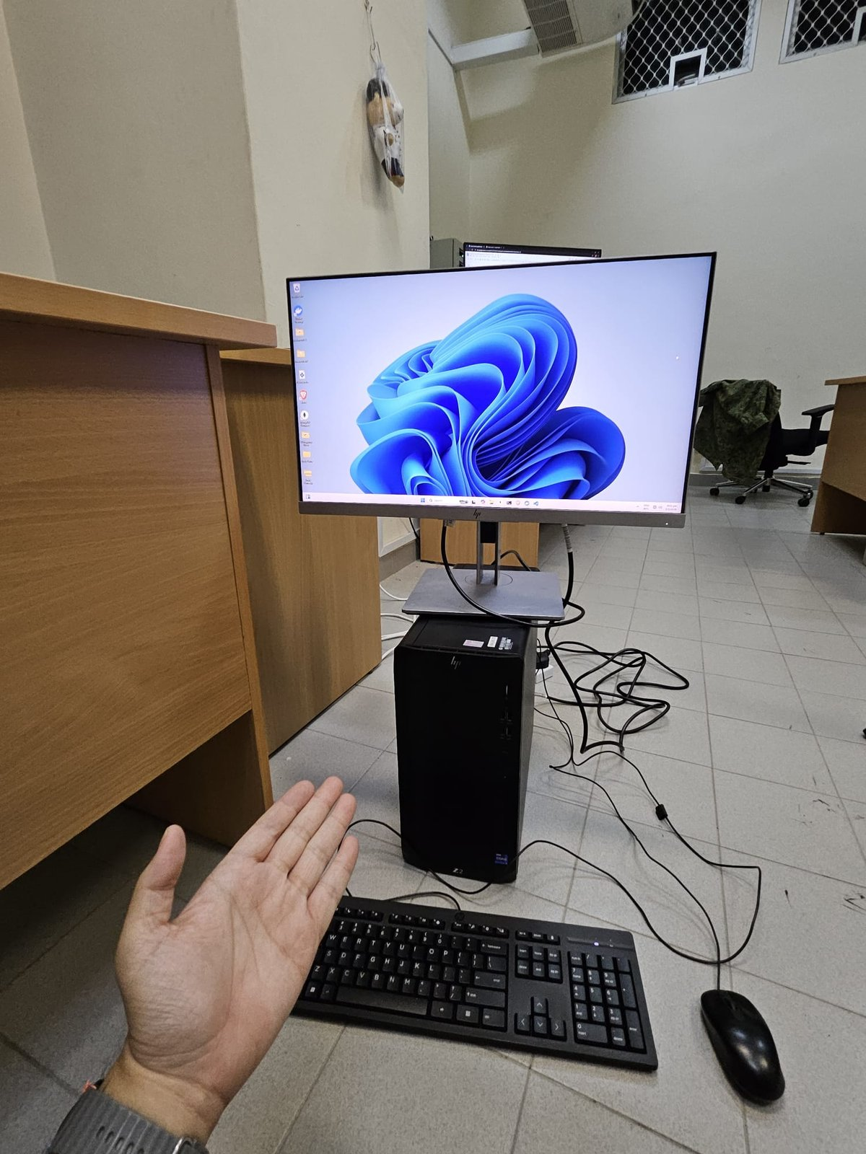
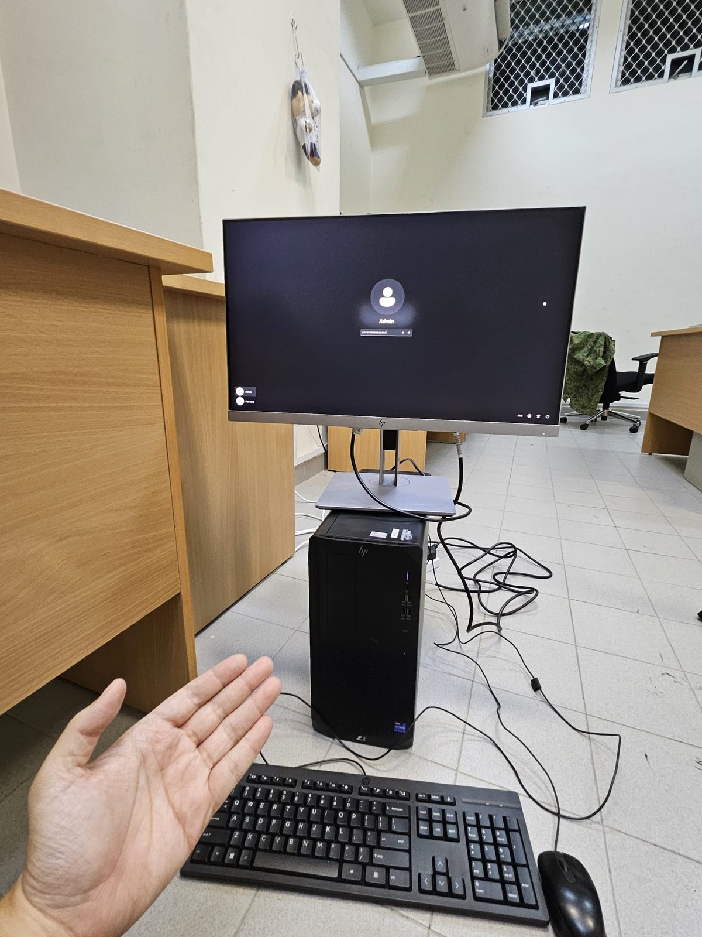
- Repeat ( Step I to IX ) for the second desktop set up
- Setting up the camera and the network switch
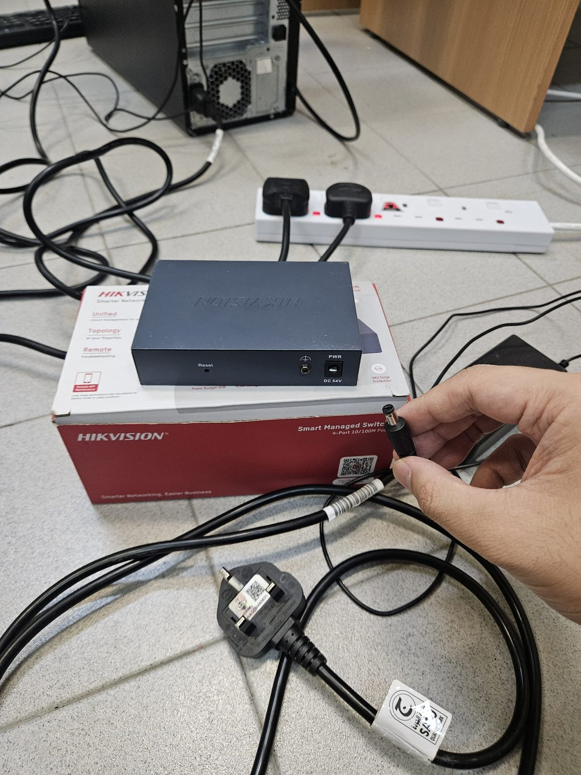
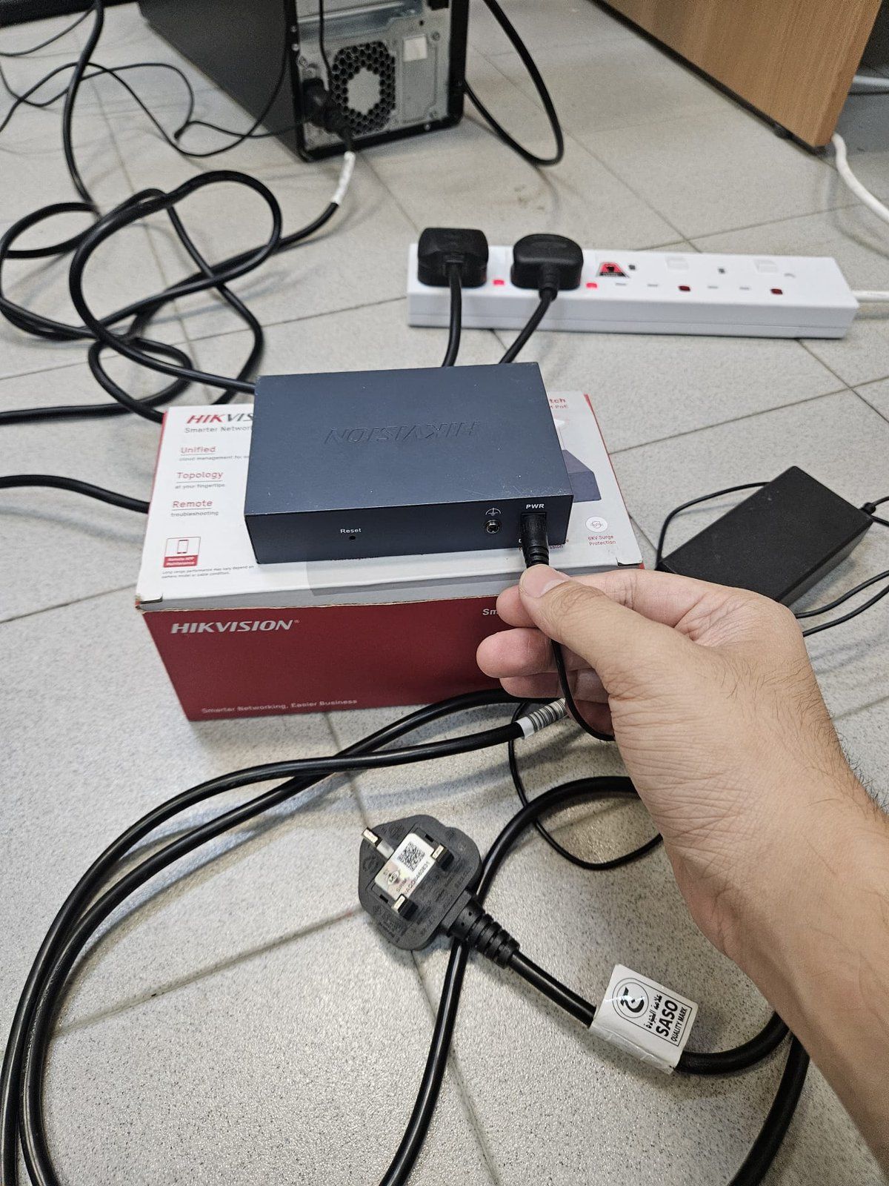
  - Plug the network switch’s power cable into the network switch (The network switch power cable is in the network switch’s box) **DO NOT MIX UP THE POWER CABLE WITH THE OTHERS**

B. Plug in the power cable into the soapbar.
C. Connect both PCs to the network switch with LAN cables. This is needed if the gallery will run on the second PC.
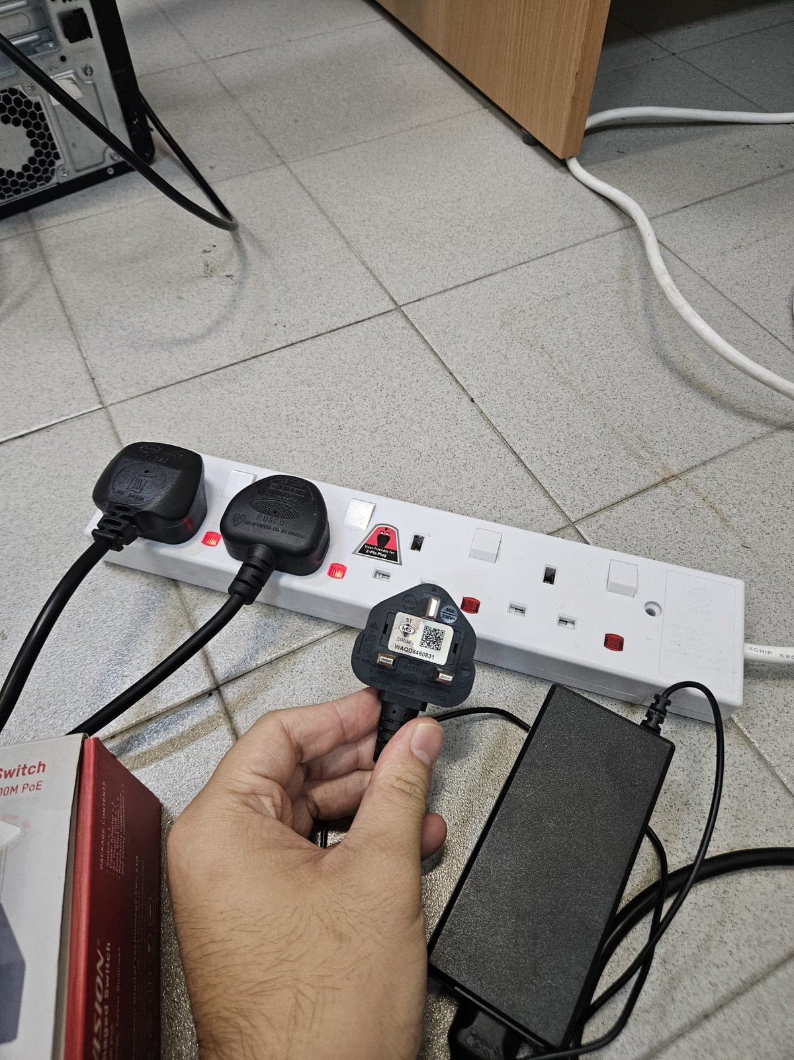
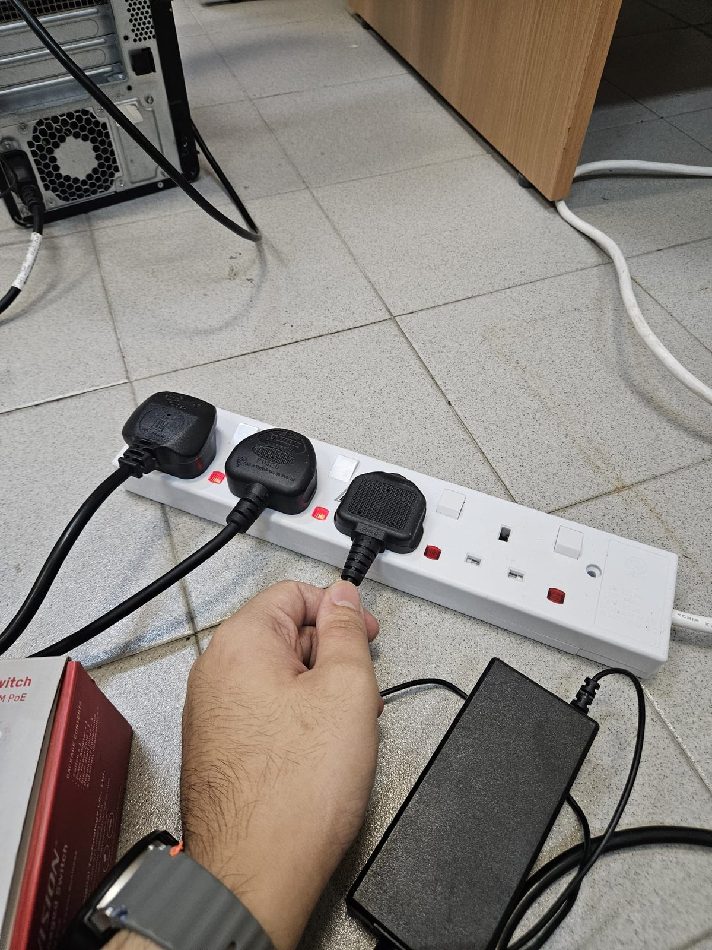
Do not plug any LAN cables into the UPLINK port. It only draws network connection and does not give the PCs or the camera power.
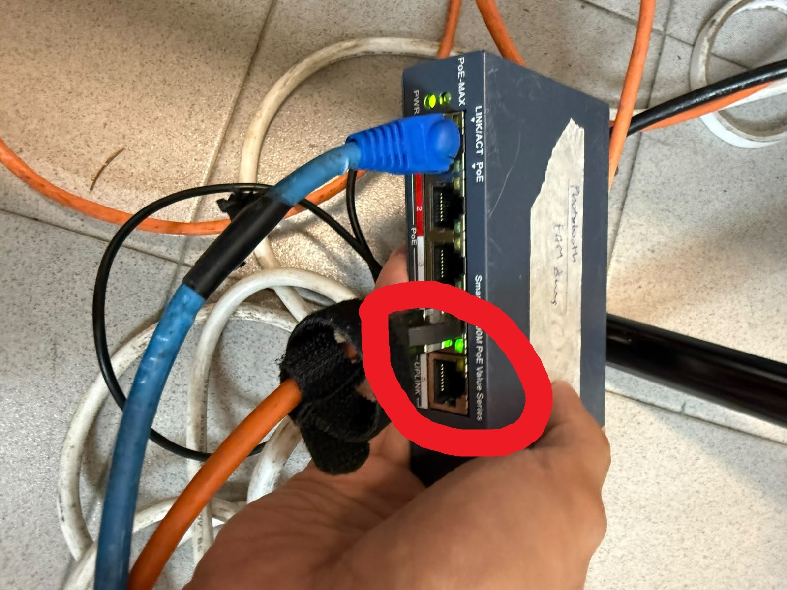

2. Software Setup

Prerequisites
- Visual Studio Code (or an equivalent code editor)
- Docker Desktop and Docker Compose
- NVIDIA GPU driver (required by the backend, and for GPU support in Docker)
- Python 3.11 (for running the photobooth backend in development)
- PyTorch, GPU/CUDA build (for running the pose and hand detection models in development) (ENSURE IT IS USING GPU BUILD INSTEAD OF CPU BUILD; will result in substantial video lag if wrong)
- FFmpeg (for reading RTSP IP camera streams in development)
- fnm (for installing and switching Node.js versions)
- Node.js 18.x (for running the booth and gallery frontends in development; newer versions break the project)
- Yarn 3.2.3 or later (for installing and running the frontends; comes with Node 18)
- Git (for development version control and pulling/pushing updates from GitHub)

Installing and Running Photobooth
Open Docker Desktop. There may or may not be containers already present in the menu.
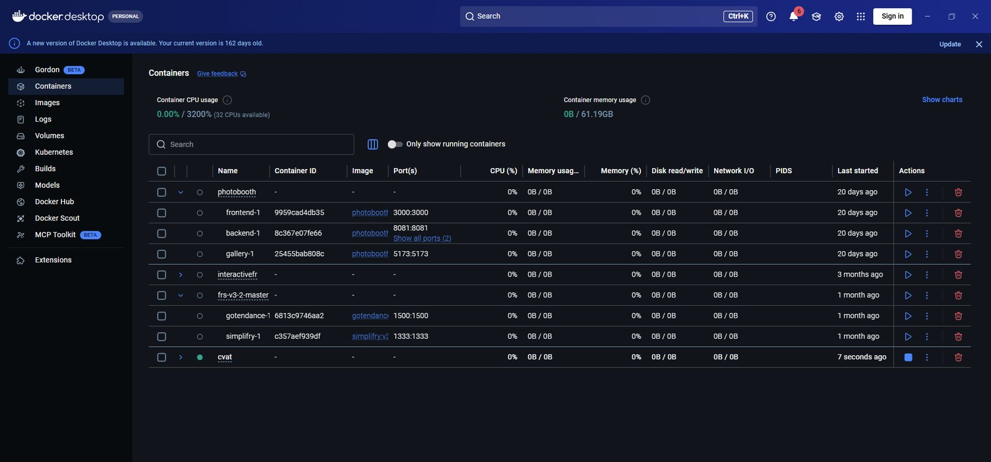
Navigate to https://github.com/Cooleststar/NS-Photobooth/tree/main. Installation instructions are also provided on GitHub, but this guide will walk through the installation with more detail.
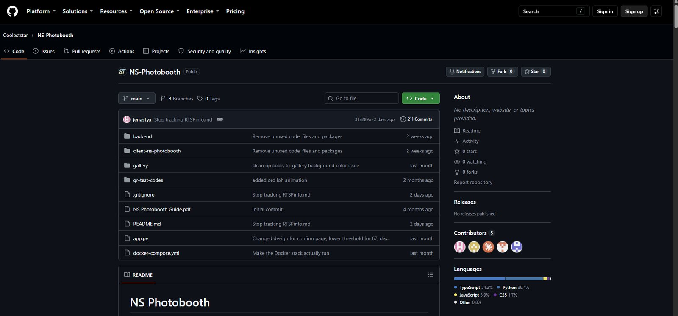Select the green “code” button and download the zip file (alternatively use git clone if you are familiar with that)
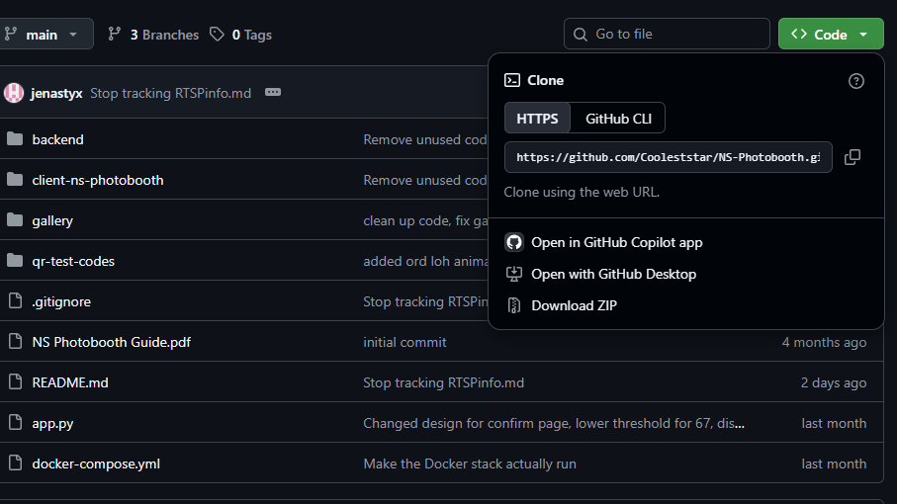Once downloaded, extract the zip file to your desired location (e.g. Desktop). It should look like this
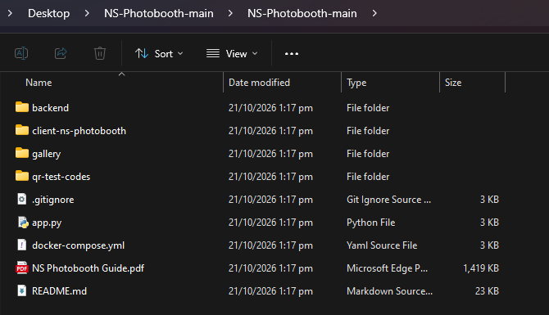
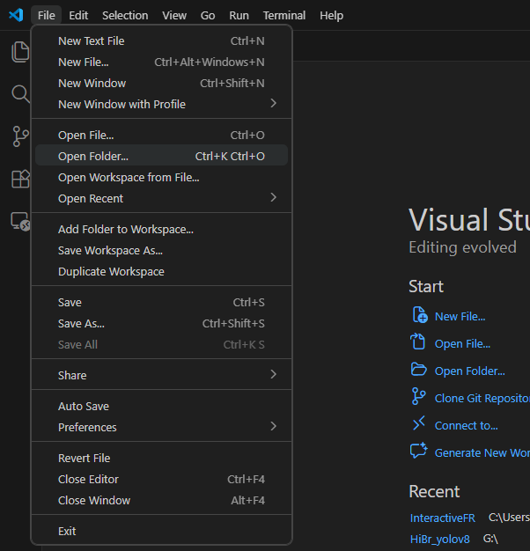
Open VSCode and open the NS-Photobooth-main folder that was just installed. (File > Open Folder > Select folder in popup)

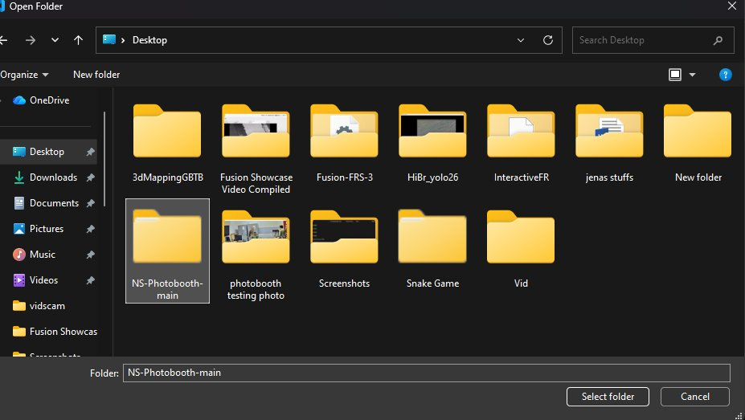
To open the terminal, click Terminal in the menu bar at the top left of VS Code, then click New Terminal.
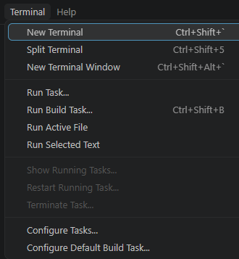
If the terminal shows C:\Users\Admin\Desktop\NS-Photobooth-main>, type cd NS-Photobooth-main and press Enter to move into the inner project folder.
Type the command “docker compose build” into the terminal and press enter. Wait for the command to finish execution. For first-time installation, this may take several minutes.
Once the containers are built (indicated by green tick), type “docker compose up” into the terminal and press enter. Take note that it may take some time for the images to load.
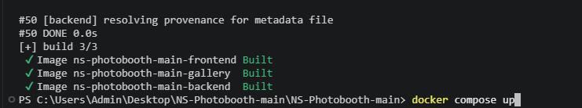
Back in Docker Desktop, there should be a set of containers that are running (indicated by a green circle). The exact name of the application is ns-photobooth-main. This application can be stopped and started using the blue play/stop button on the right. In the future, there is no need to run the terminal commands for build/up anymore, simply open Docker Desktop and click the play button.
There are three separate applications: frontend, backend and gallery. The frontend (the photobooth itself) can be accessed via http://localhost:3000, and the gallery can be accessed via http://localhost:5173/. (more explanation in gallery section) The backend has no link to open: it's the engine that reads the camera and runs the pose and hand detection, and the frontend connects to it automatically in the background. Nothing is shown in the browser for it, so you only need to check that it is running (green circle) in Docker Desktop.
After pressing play, give the backend a little while to load its models before the booth works. Until then the page may look blank or show no camera.
Optional: For developers (more details on github readme)
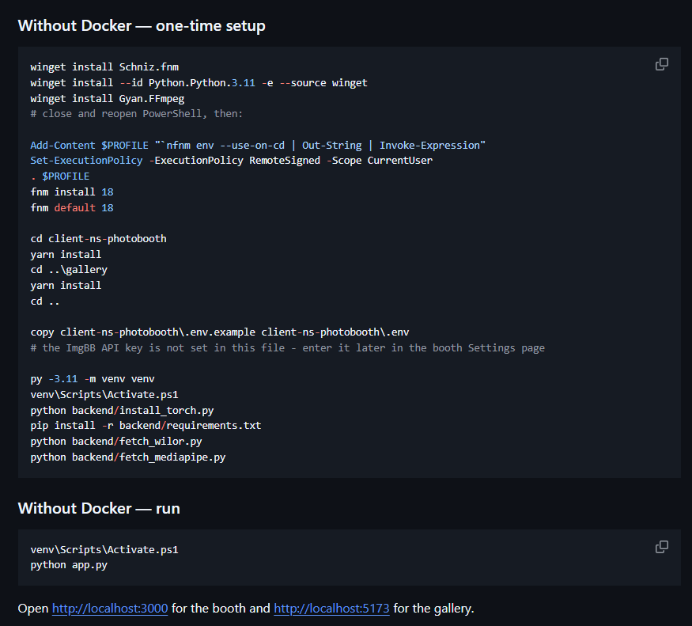

Starting photobooth
There are three applications as part of Photobooth: frontend (localhost:3000), backend (localhost:8081) and gallery (localhost:5173).
- Frontend: the photobooth itself. This is the page guests and operators use. It shows the live camera feed with the animated characters, takes the photos and holds the Settings panel.
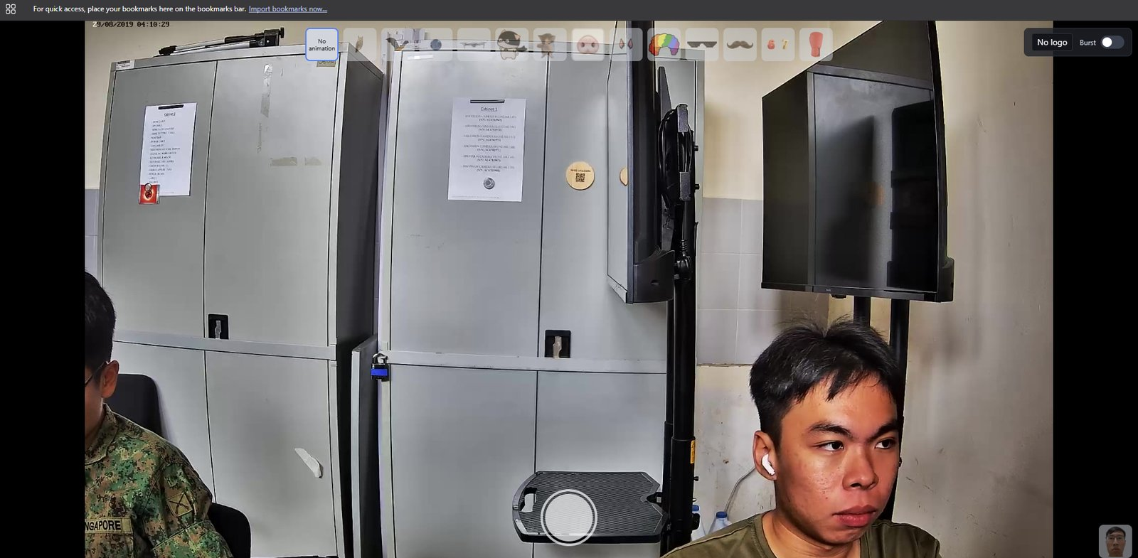
- Backend: the engine behind the scenes. It reads the camera, runs the body and hand detection that tells the characters where to appear, and saves the photos. There is no page to open at its address, because the frontend connects to it automatically.
- Gallery: a separate website for looking at the saved photos afterwards. Anyone on the same network can open it to browse, download or delete photos. To run it on the second PC, both PCs must be connected to the network switch.
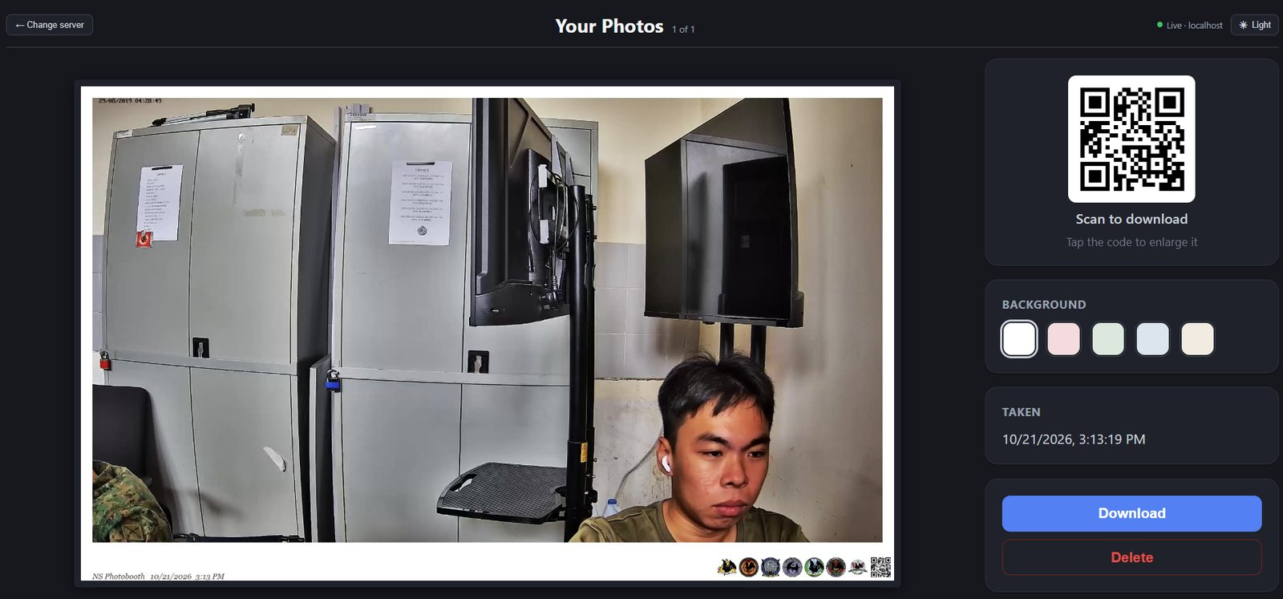
For frontend setup,
- Navigate to http://localhost:3000/. You should see a startup screen.
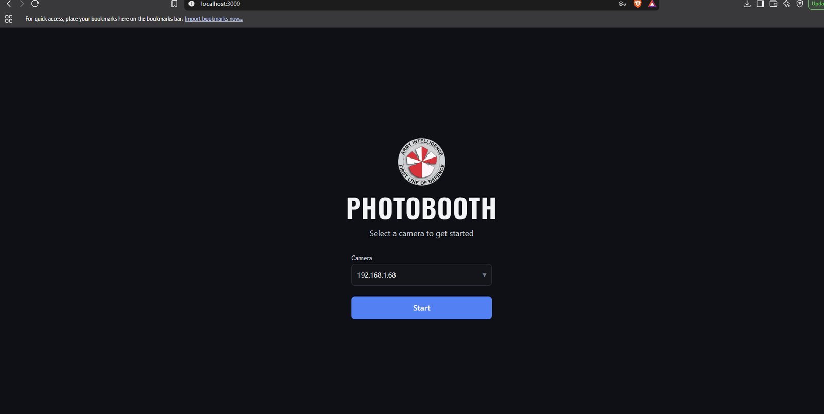
- Select the IP camera source. This is written on the bottom of the HIKVISION camera. The IP addresses for Fusion’s HIKVISION cameras are already indicated in the dropdown.
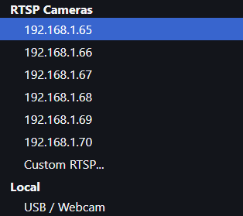
- If using another IP camera, click on “Custom” and enter the RTSP URL for that camera (depends on the camera, check with manufacturer).
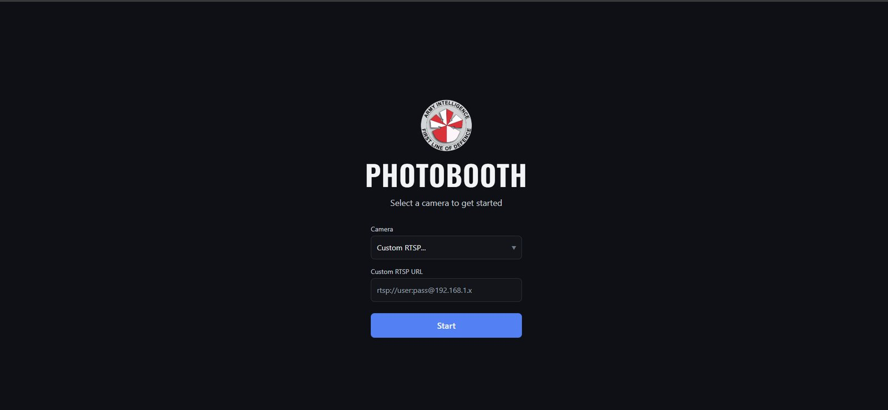

Using USB/webcam
- If you are using a USB/webcam, make sure the browser is using the correct camera. Open your browser's camera settings, either by typing the address below into the address bar or by going to Settings , Privacy and security, Site settings, Camera, and select the correct camera:
  - Chrome: chrome://settings/content/camera
  - Edge: edge://settings/content/camera
  - Brave: brave://settings/content/camera
  - Firefox: about:preferences#privacy, then scroll to Permissions and open Camera → Settings
Also check that the site (localhost:3000) is set to Allow for the camera. If you change the camera while the booth is open, reload the page for it to take effect.
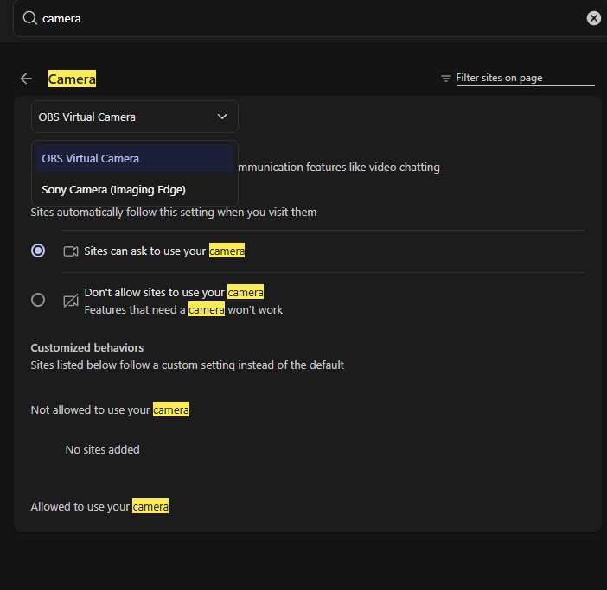
- Wait for the app to finish starting up. The first load may take some time, because the backend needs to download and load its detection models. Until it is ready, the page may be blank or show no camera.
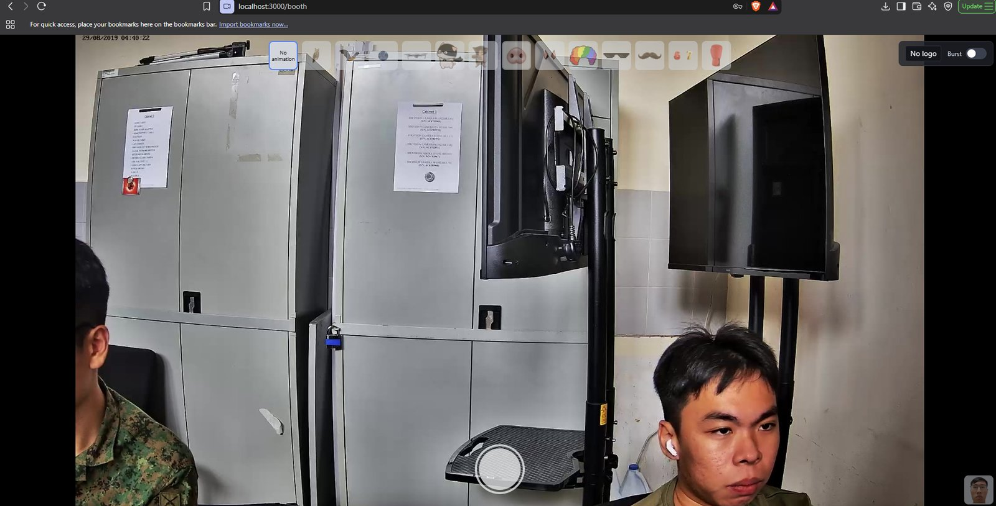

Gallery setup
- Navigate to http://localhost:5173/. You should see a startup screen.
- Enter the IP address of the photobooth PC, which is the computer running the backend that stores the photos. Which address to type depends on where you open the gallery:
- On the photobooth PC itself: enter localhost. This is already filled in by default.
- On the second PC: enter the photobooth PC's network (IPv4) address, which looks like 192.168.1.x. To find it, open the terminal on the photobooth PC and run ipconfig. The address is the IPv4 Address listed under the active connection (Wi-Fi or Ethernet). Both PCs must be connected to the same network switch with LAN cables, or the gallery will not be able to connect.
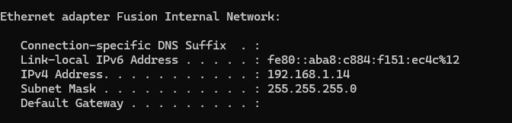
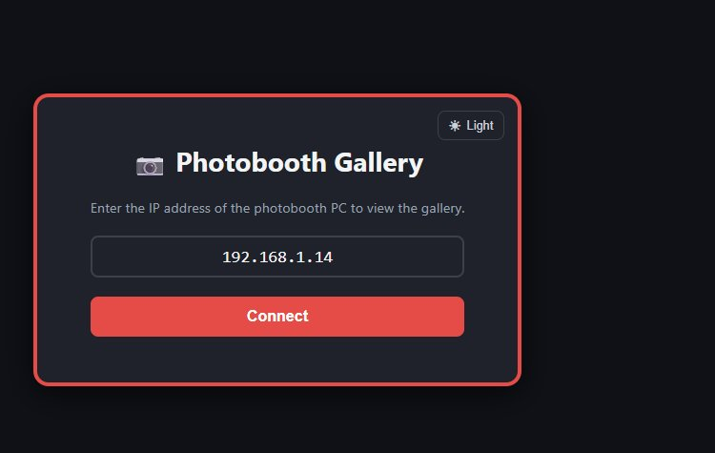
- Click Connect. The gallery remembers the address, so you only need to enter it once.
On the second PC, open the gallery using the photobooth PC's IP in the address bar (for example http://192.168.1.x:5173/), not localhost. On that PC, localhost points to the PC itself, not the photobooth PC.
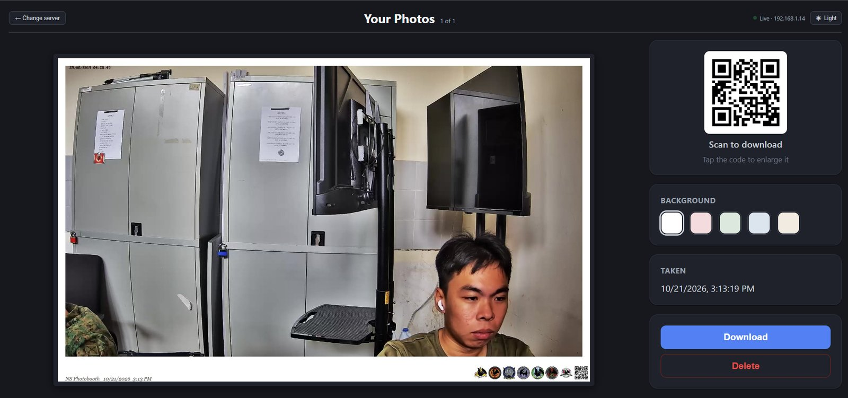

3. The booth screen
Along the top of the screen is a row of small pictures. Each is a character.
To switch a character on or off, click its picture. Selected ones are bright, and you can have up to 5 on at once.
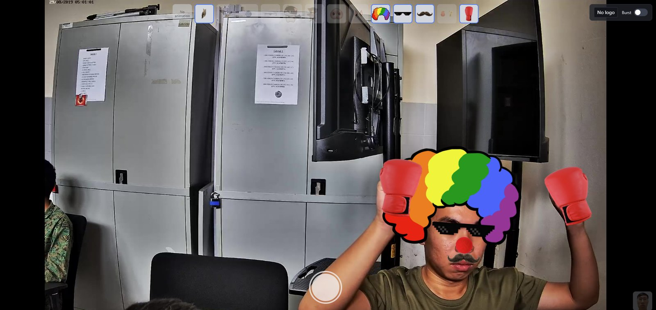
Some pictures are greyed out and can't be clicked. That means they clash with one already selected, or the limit of 5 is reached. Hover over it to see the reason.
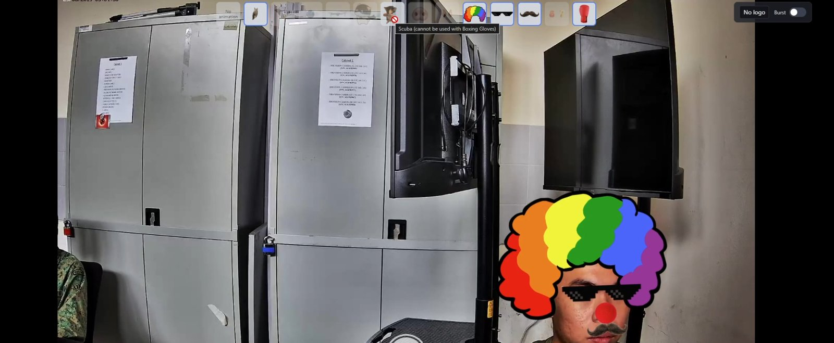
The No animation button clears them all.
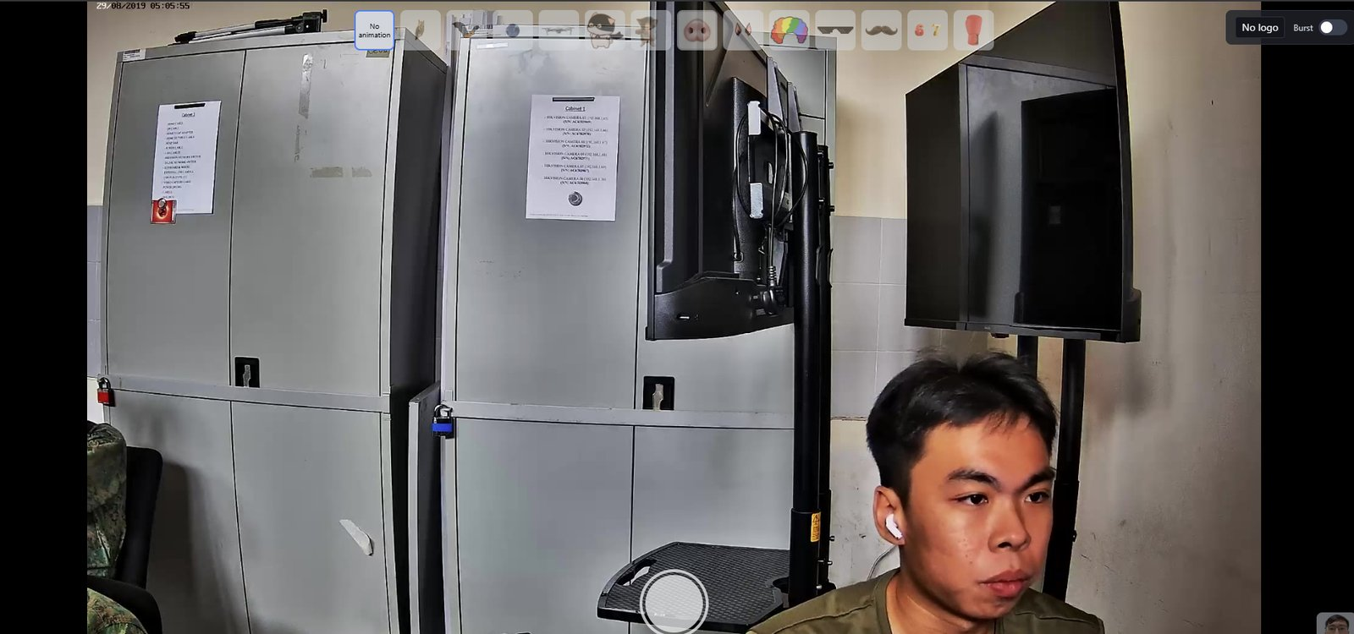
Stand in front of the camera and, if the character needs a gesture, make it. Here is what triggers each one:
- Owl, Bat, Caped Cat: hold a bent arm out to the side, and the character lands on your forearm. You can only have one of the three on at once. The bat needs your hips in view.
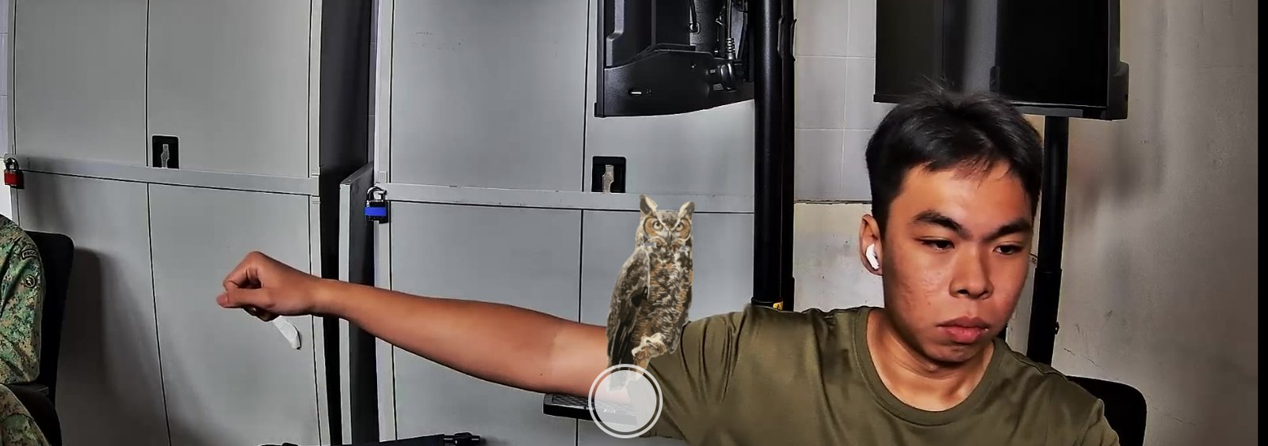
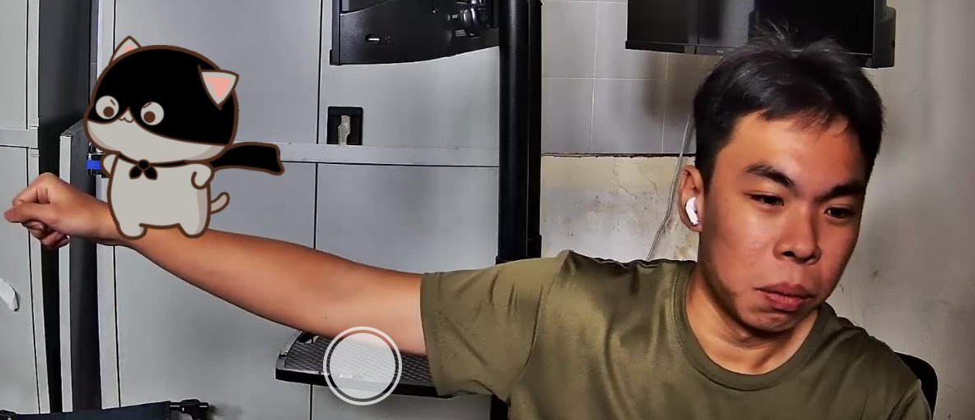
- Globe: it orbits your body by itself. Hold your hands apart and it moves between them.
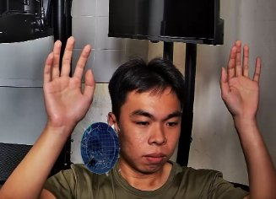
- Drone: hold an open palm up, facing the sky.
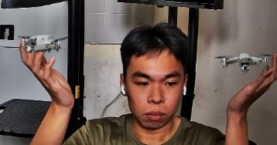
- 67: hold both palms up with your arms out diagonally, one hand higher than the other. A 6 and a 7 appear above your hands.
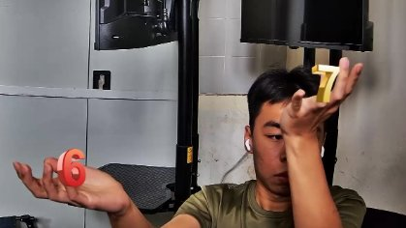
- Scuba: wave a hand from side to side.
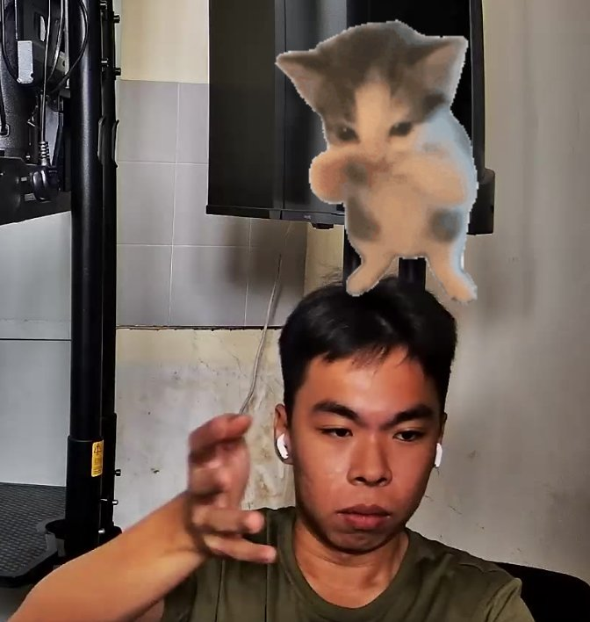
- Boxing Gloves: make a fist, and a glove appears on that hand. Dizzy stars show when a glove swings near someone's head.
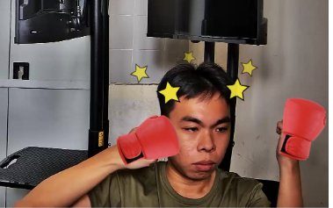
- Pig Nose & Ears, Bat Ears, Clown Wig & Nose, Sunglasses, Mustache: no gesture needed. They appear on your face as soon as the camera sees it.
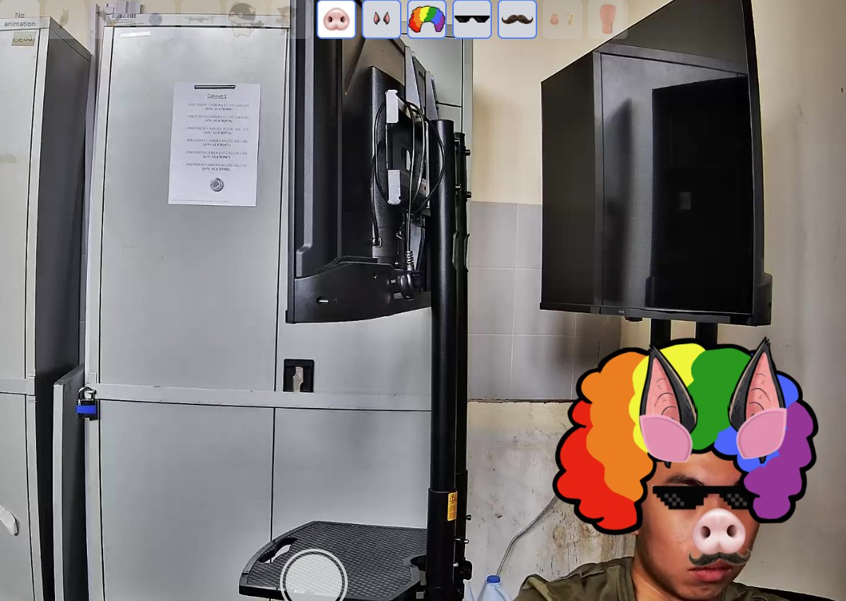
Characters usually take a moment to appear, because a gesture has to be held briefly before it counts. This avoids setting them off by accident.
To take a photo, press Space on the keyboard, or click the round shutter button at the bottom centre of the screen. If a banner logo is showing, the button is hidden and only appears when you hover over its spot.
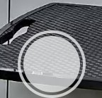
A countdown starts (3 seconds by default). Get into position.
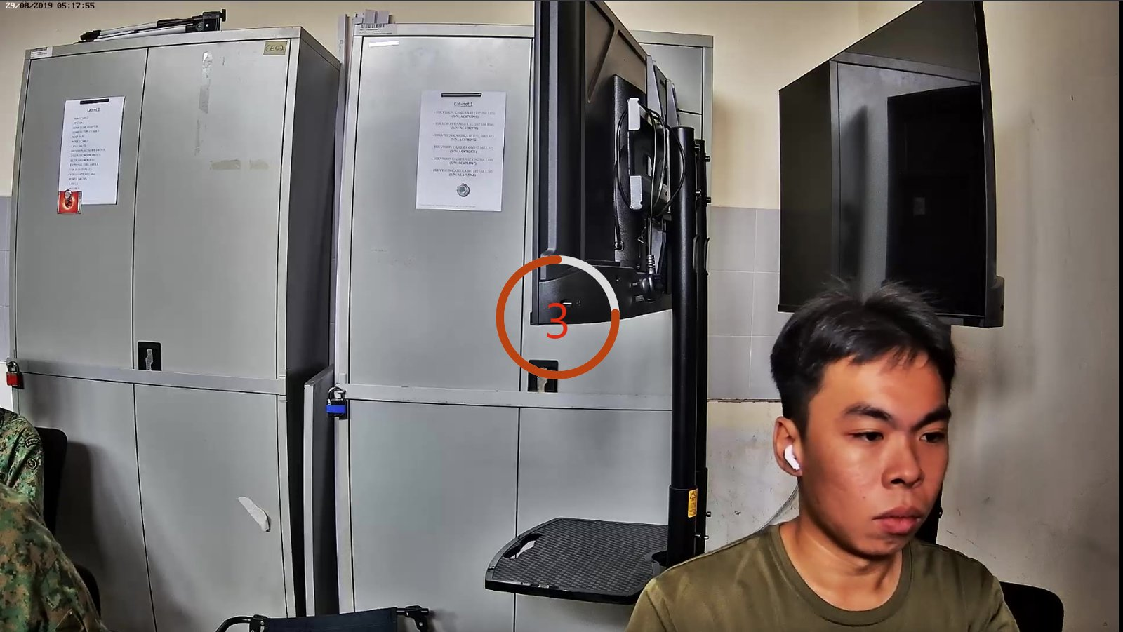
If Burst is on (More explanation on burst section), you'll see "Photo 1 / 3", and so on, as it takes several shots one after another.
A preview window titled Confirm? appears.
- Click Confirm (or press PageUp) to keep the photo.
- Click Cancel (or press PageDown) to discard it and retake.
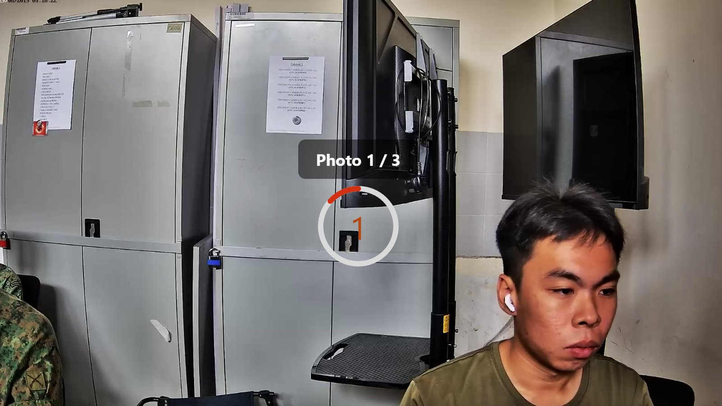
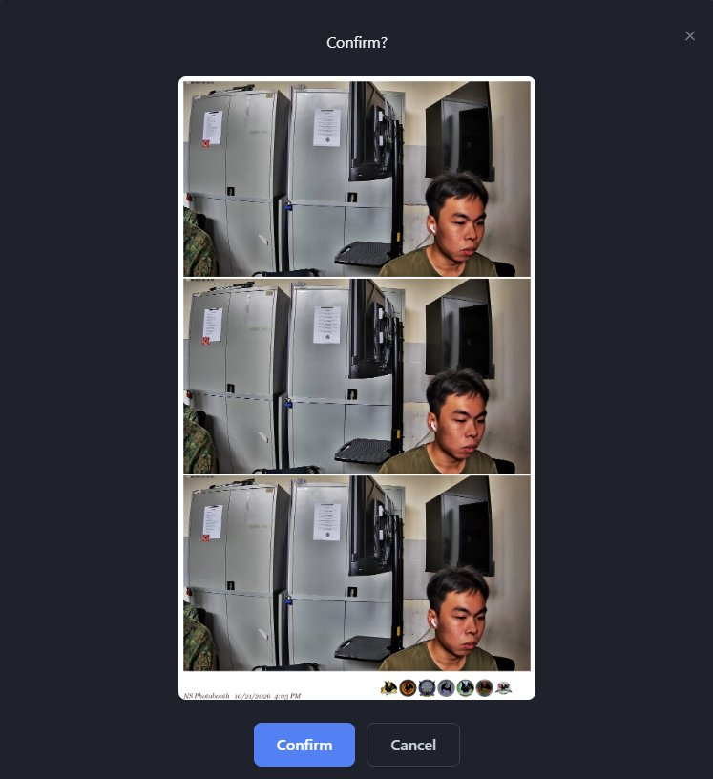
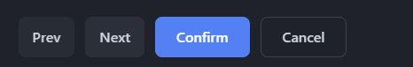
If there is more than one strip, use Prev and Next (or the left and right arrow keys) to look through them.
If online features are on, the screen shows Uploading... for a moment. When it's done you're back on the live view.
If an Error window appears, click Done (or press PageUp), then try again

4. Settings
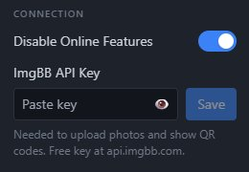
Turning off online features also turns off the gallery.
The ImgBB API Key decides which ImgBB account the photos are uploaded to. Follow the steps below to get one.

How to get ImgBB API Key
Go to https://imgbb.com/
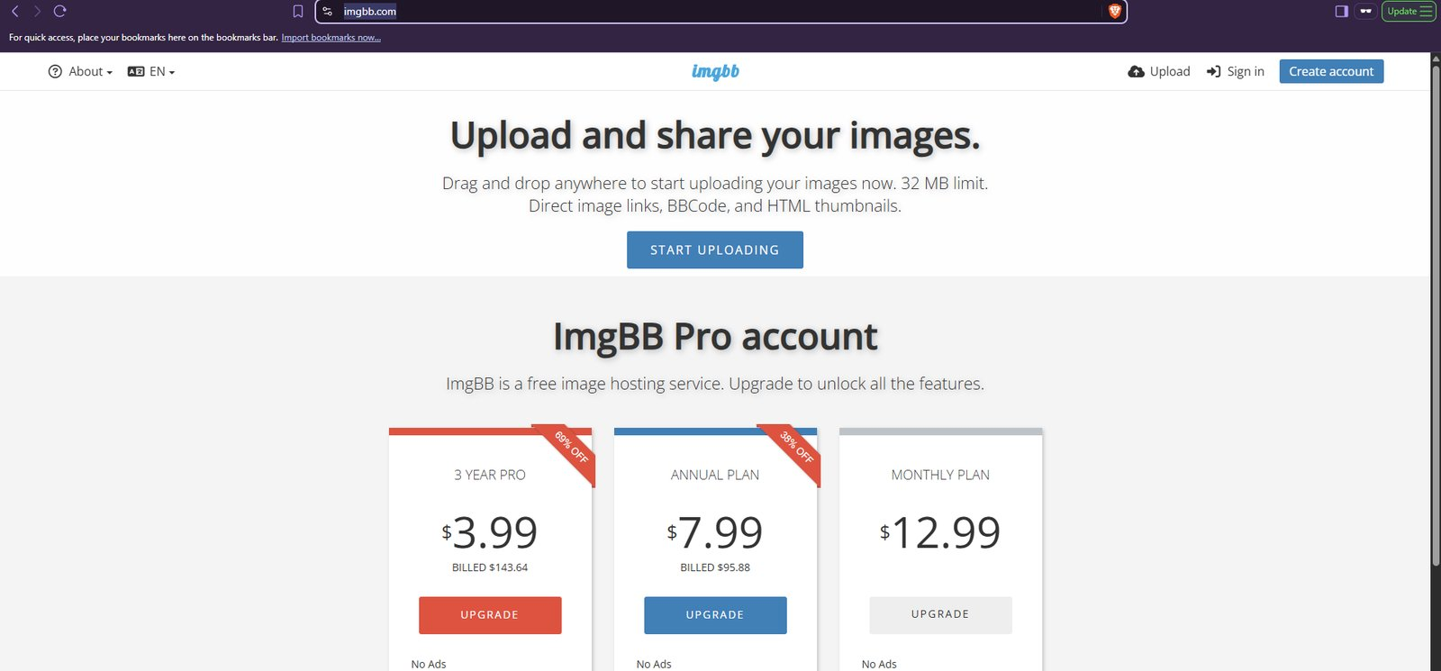
If you do not have an account yet, click Create account.
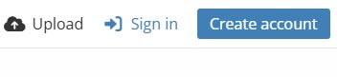
Enter your email address, username and password, then accept the terms and privacy policy.
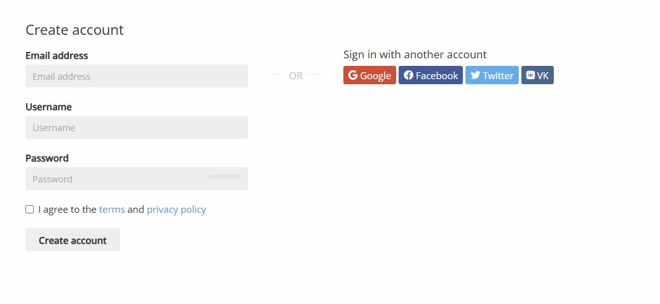
ImgBB will send you a verification email. Open it and follow the instructions to verify your account.
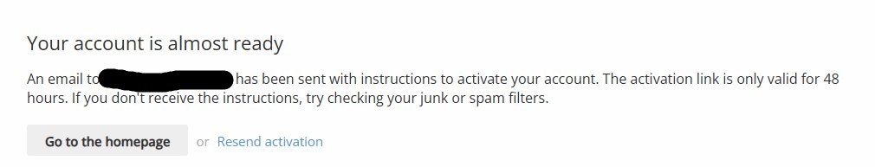
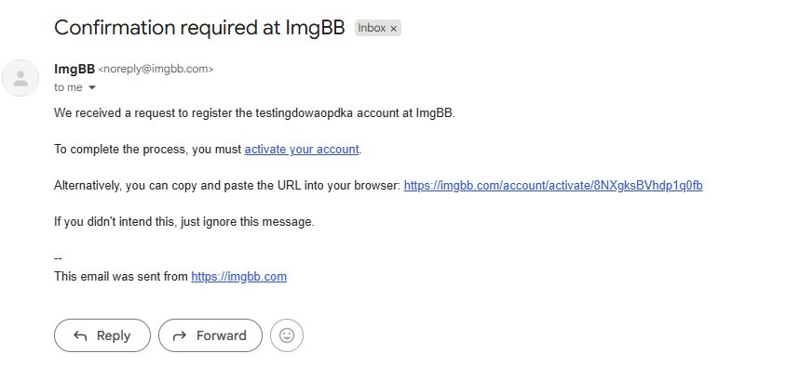
Once you are signed in, click About, then API.
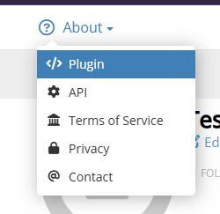
Copy the API key and paste it into the ImgBB API Key field on the Settings page.
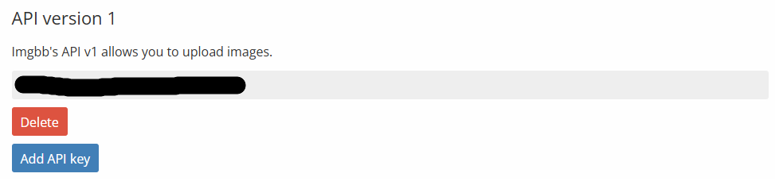
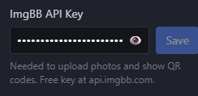
Current ImgBB account settings:
- Uploaded photos are deleted automatically after 3 days.
- Photos can only be viewed through their generated share link, not from the ImgBB account page. This is controlled by the account's anonymous setting.

Canvas Size
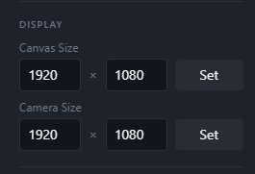
The rendering surface everything is drawn onto such as the live feed, every animated character, and the banner logo. This is what determines the resolution of captured photos.
Raise it for higher-quality photos; lower it if rendering is struggling. It does not affect what the camera captures or what the pose detector sees.

Camera Size
The resolution requested from the camera itself. Modify this to match what the camera is capable of.

Mirror
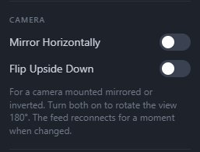
Mirrors the videofeed. (similar to looking at yourself in a mirror) only toggle if videofeed is inverted.

Flip Vertically
Flipping the camera vertically in an event where the camera is flipped.

Countdown
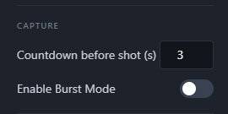
Modifies the time required before the camera takes a shot.

Burst Mode
Toggles on burst mode which takes 3 extra photos all affected by the countdown.

Animation GIF
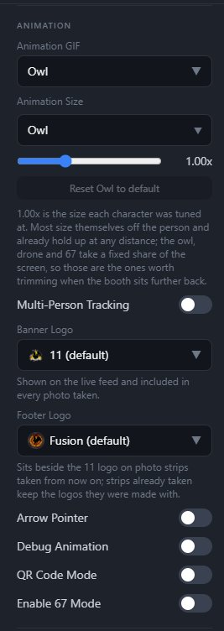
Shows the animation currently displayed. Can also be used to select multiple animations concurrently.

Animation Size
Modifies how big an animation will appear, an important feature when using the camera at a far distance or close distance from a person. (this feature only is not global, meaning it affects animations individually.)

Reset Button
Sets the size of the animation back to default.

Multi-Purpose Tracking
Multi purpose tracking is the ability to track Limbs on 1 or more users.

Banner Logo
Banner logo shows up on your screen while taking photo. Can select more than 1 banner. Will appear within the photo taken so reference the live position of the banner.

Footer Logo
Shows up at the footer of the photo once it is taken.
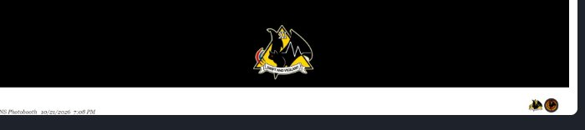
For reference after photo was taken.

Arrow Pointer
Drops a moving animated arrow pointing down on top of all the detected people’s head
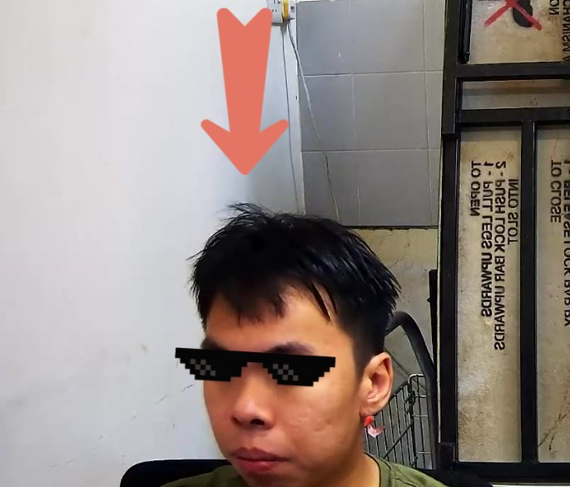

Debug Animation
Shows the joints of all the detected body parts of a person
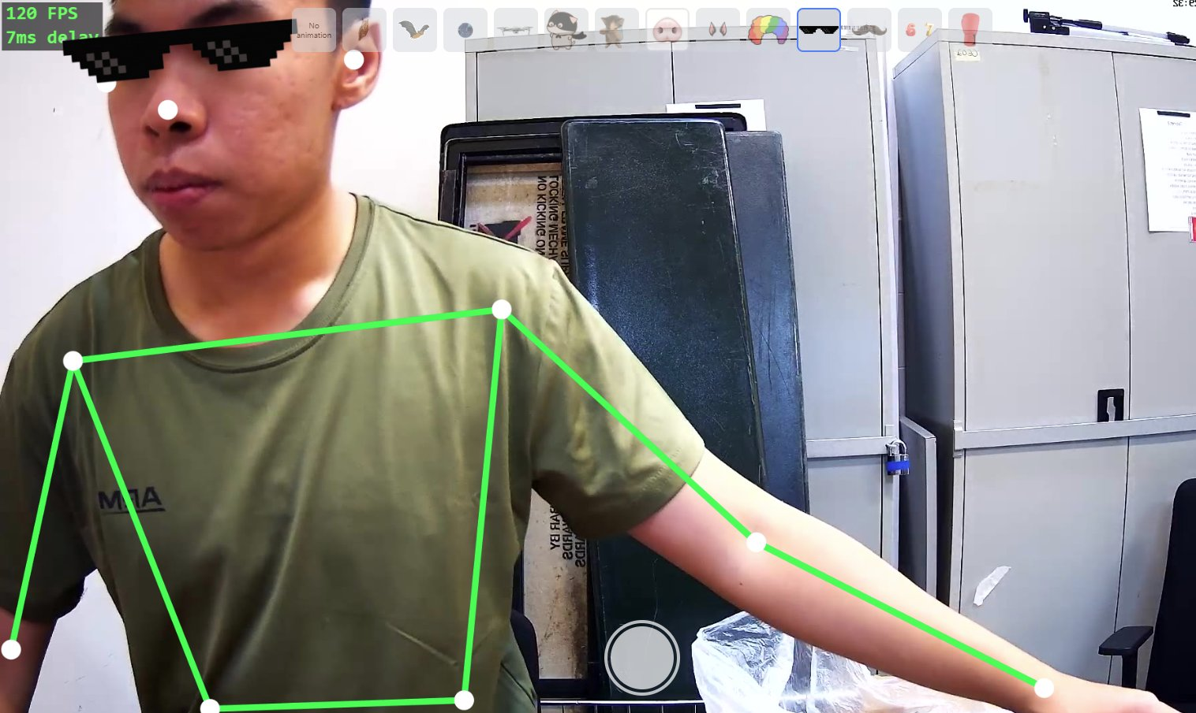

QR Code Mode
Uses a QR code on screen to generate animations on target. (not in used usually)

Enable 67 Mode
Starts the inbuilt 67 game. (More explanation on 67 section)
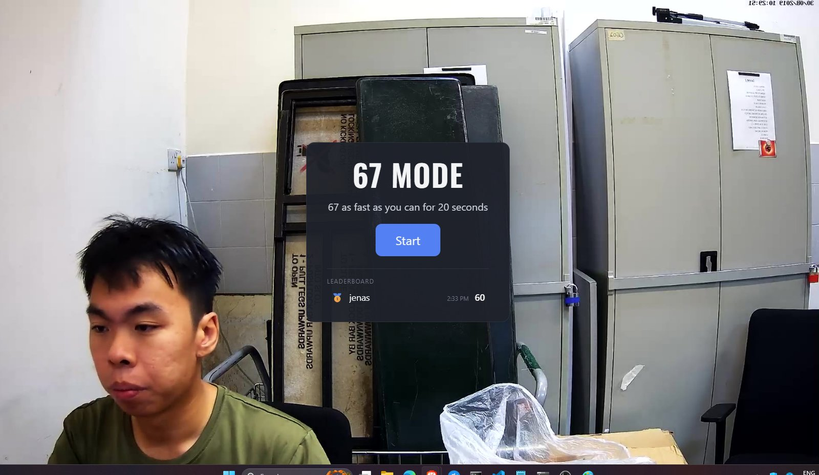

Leaderboard
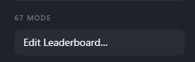
Allows you to modify the leaderboard stored within the local device for the 67 mode.( More explanation on edit leaderboard section)
The password is : password123

Test Video
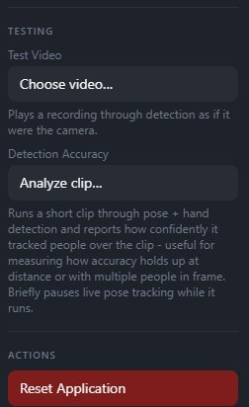
Choose a video that you want to be played back as the camera footage. (used in testing animations) Usage would be in the event where it is not convenient to test live footage but rather a recorded video of the location. (More explanation on the Test Video Section)

Detection Accuracy
Shows confidence in tracking users. (More explanation on the detection accuracy section)

Reset Application
Similar to refreshing the browser, but it also changes all the settings back to their defaults. After a reset, you will need to select or enter the camera IP address again on the startup screen.

5. Gallery Page
On the gallery page, you’ll see Your Photos, with a counter such as “2 of 5” for example.
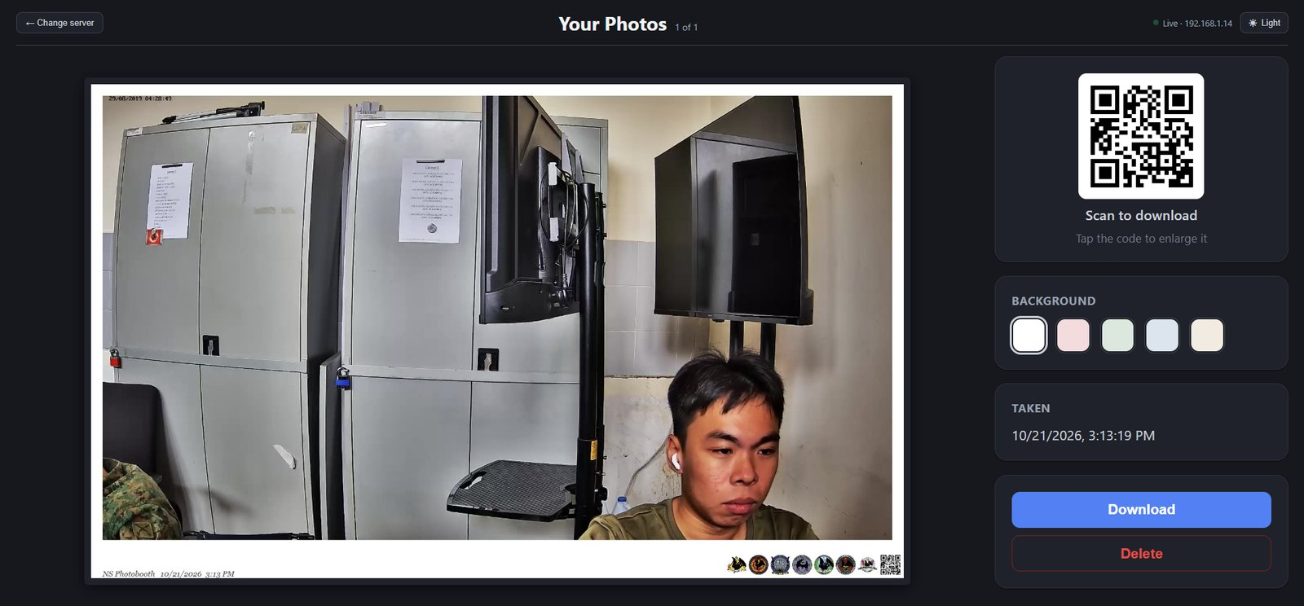
If it says “No photos yet”, take a photo on the photobooth first and confirm it. It appears here automatically.
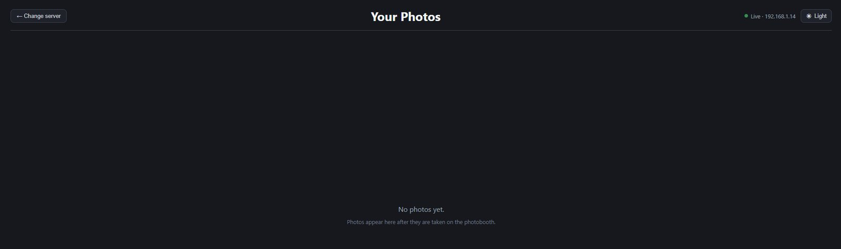
A strip of small pictures (thumbnails) shows every photo, each with the time it was taken. Click one to open it in the large view.
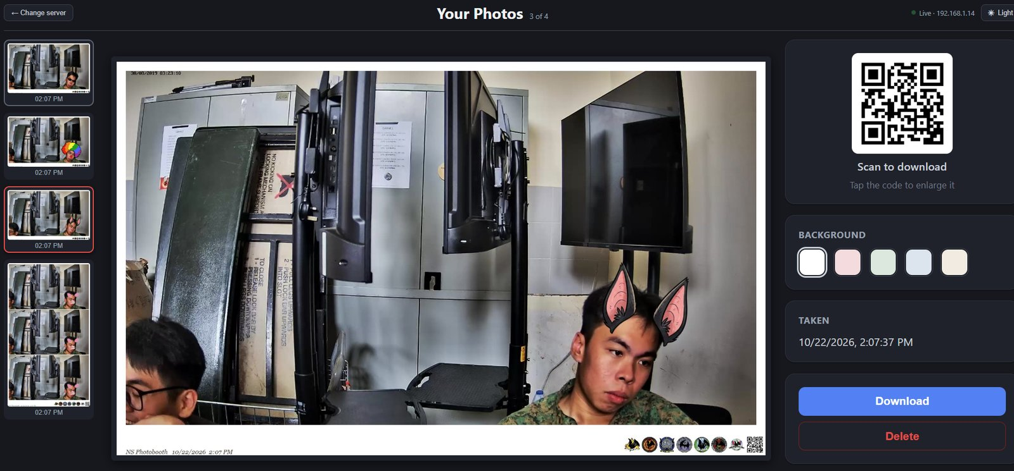
The badge at the top right shows Live · [address] when connected. New photos appear on their own, so you don't need to refresh. If it says Disconnected, the photobooth has stopped, the network dropped, or one of the PCs is no longer connected to the network switch.
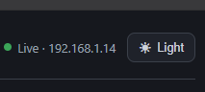

QR Code and Download
- Select the photo. If it was taken with online features on, a Scan to download box shows a QR code beside it.
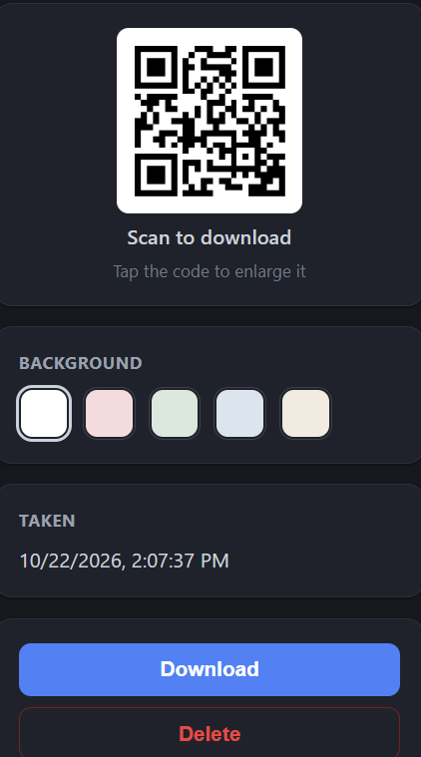
- Click the QR code to enlarge it ("Scan to download · tap anywhere to close"). Click anywhere to close it.
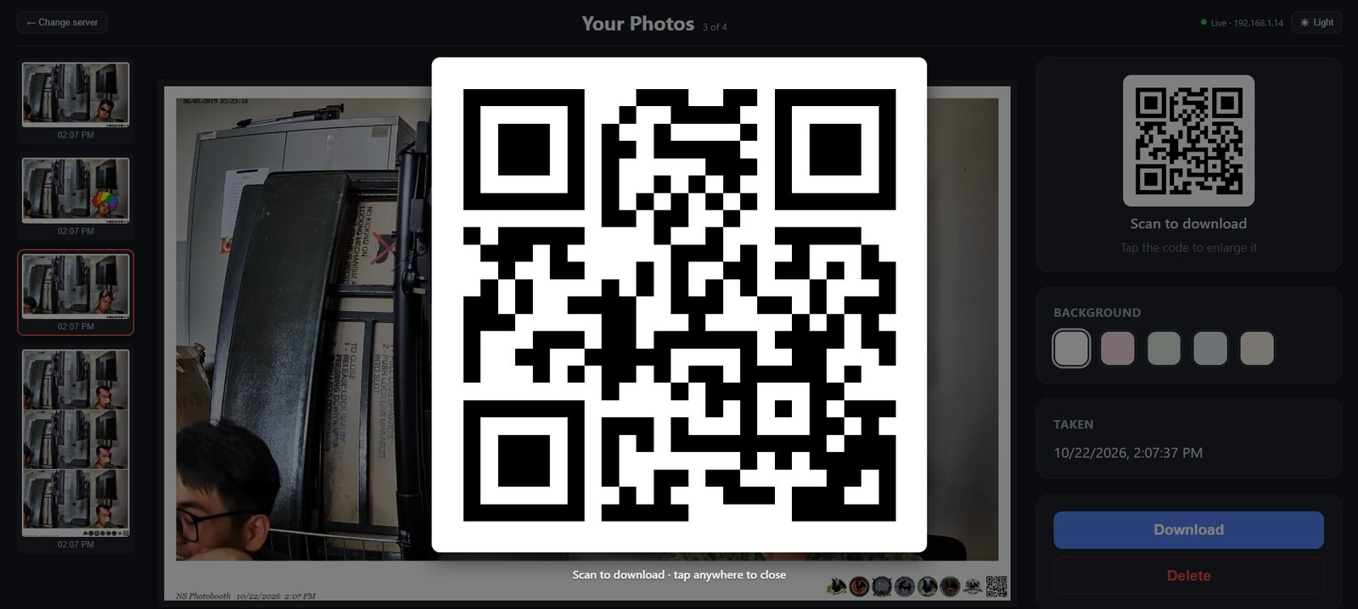
- The guest scans it with their phone camera and downloads the photo from the link.
If the box says "Saved offline — no QR", the photo was taken with online features off, so there's no QR code. Use Download instead.
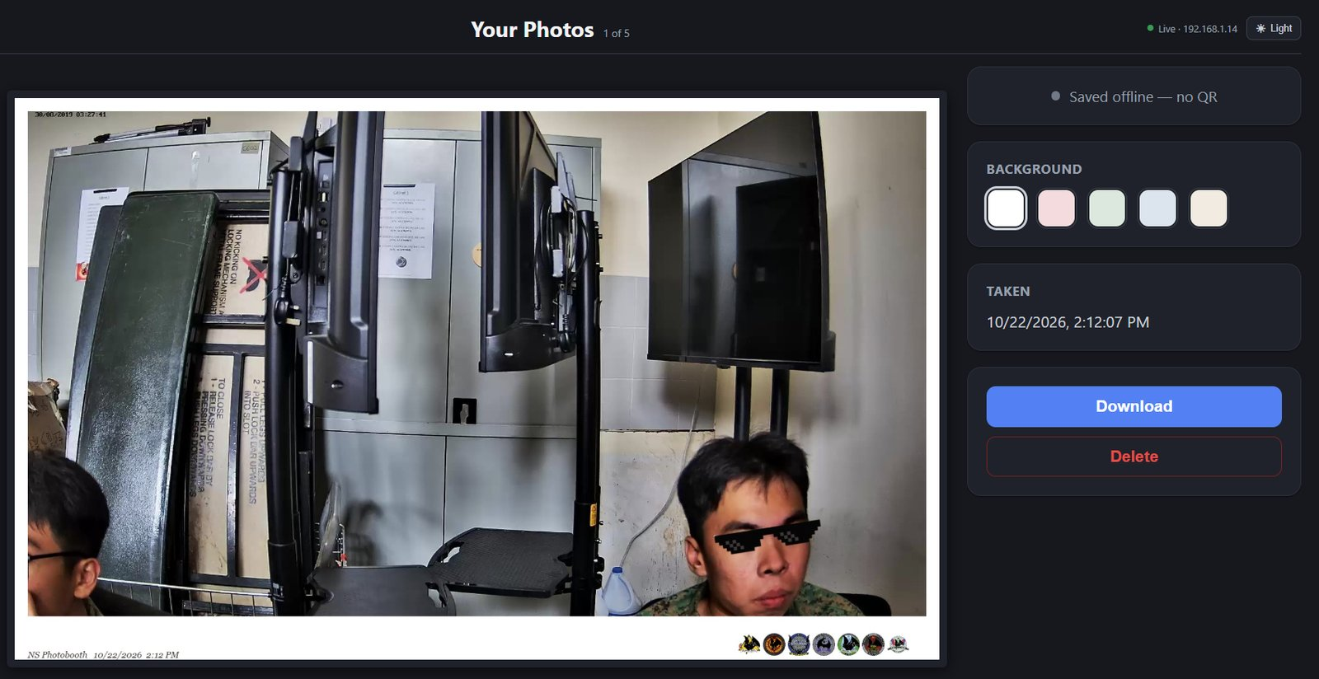
If you want to download a photo instead, select the photo and click Download. It says "Downloading…" and saves the photo to your downloads folder.
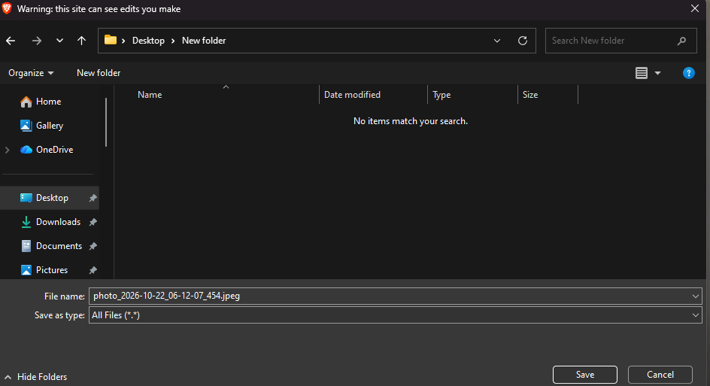

Changing the Background Colour
- Select the photo, then in the background box click one of the five colour circles (white, pink, green, blue or cream).
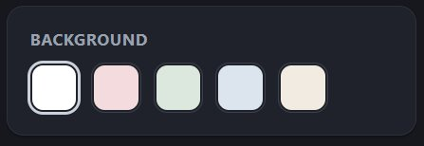
- Wait while it says "Updating colour…". The strip is redrawn and uploaded again, so the buttons are disabled until it finishes.
- This needs the ImgBB API key, because the recoloured photo is uploaded as a new file. Enter the key on the photobooth's Settings page first.
- Recolouring doesn't work on photos taken before the original shots were stored. In that case the gallery tells you to take a new photo.
- The QR code changes. The recoloured photo gets a new link, so a QR code that was already printed or scanned still opens the old colour.

Deleting a Photo
- Select the photo.
- Click Delete.

Other buttons
Change server (top left): goes back to the IP screen, for connecting to a different photobooth.
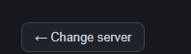
Light/Dark button. It switches between light and dark mode.
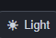

6. 67 Game Mode
67 Mode is a one-player game, where you flap your arms as fast as you can for 20 seconds, and your score goes on a leaderboard. It replaces the normal photo flow while it's switched on.

Turning On 67 Mode
- Press S to go to settings.
- Scroll to the animation section.
- Turn on Enable 67 Mode.
- Press S again, or click the X to close settings.
- The character picture bar disappears, and the 67 Mode start screen appears. It shows "67 as fast as you can for 20 seconds" and the current top scores.
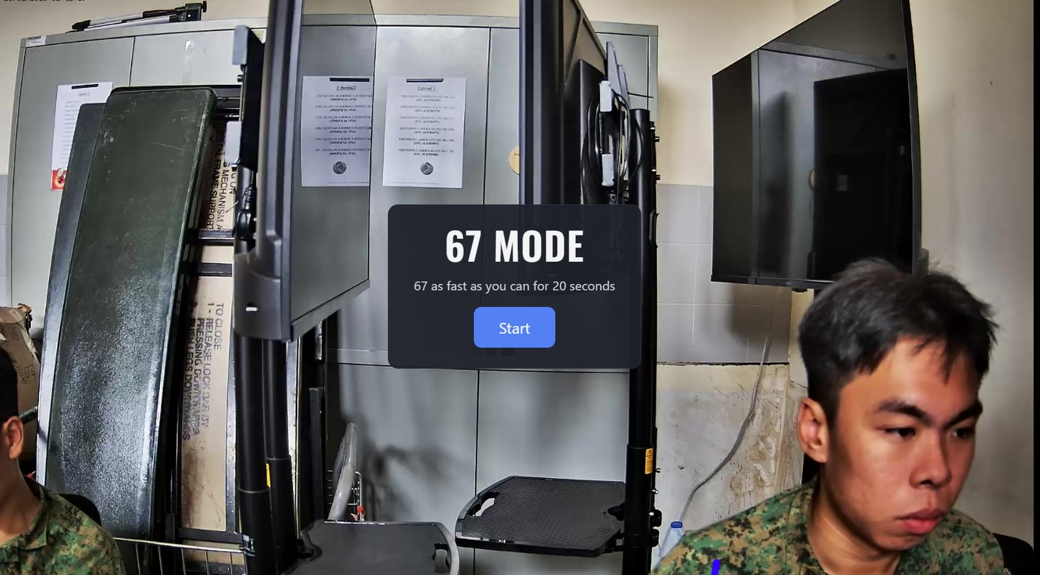

Playing a Round
- Click Start, or press PageUp.
- A box asks Enter your name. Type a name (up to 20 characters).
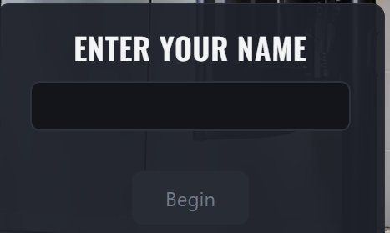
If it says "That name is already taken - try another", someone already has that name on the board. Use a different one. Capital letters and spaces don't count as different.
The Begin button stays greyed out until the name is accepted.
- Click Begin, or press Enter or PageUp.
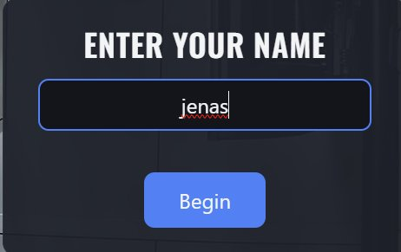
- A 3-second countdown (blue circle) runs. Get your arms ready.
- The 20 seconds start. The screen shows "Ns left" at the top and your score as a big number below it.
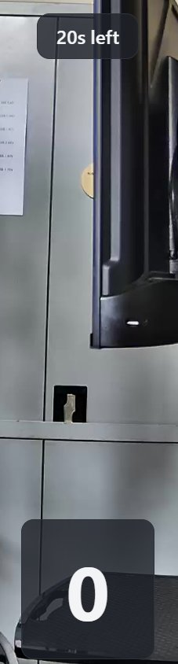

How Scoring Works
- Flap your forearms up and down, keeping your elbows roughly in place, like a quick "6-7" motion. Each flap scores 1 point, and both arms count.
- Small twitches don't count.
- Walking, swaying or swinging the whole arm from the shoulder counts for little or nothing. Keep the elbows steady and move the forearms.
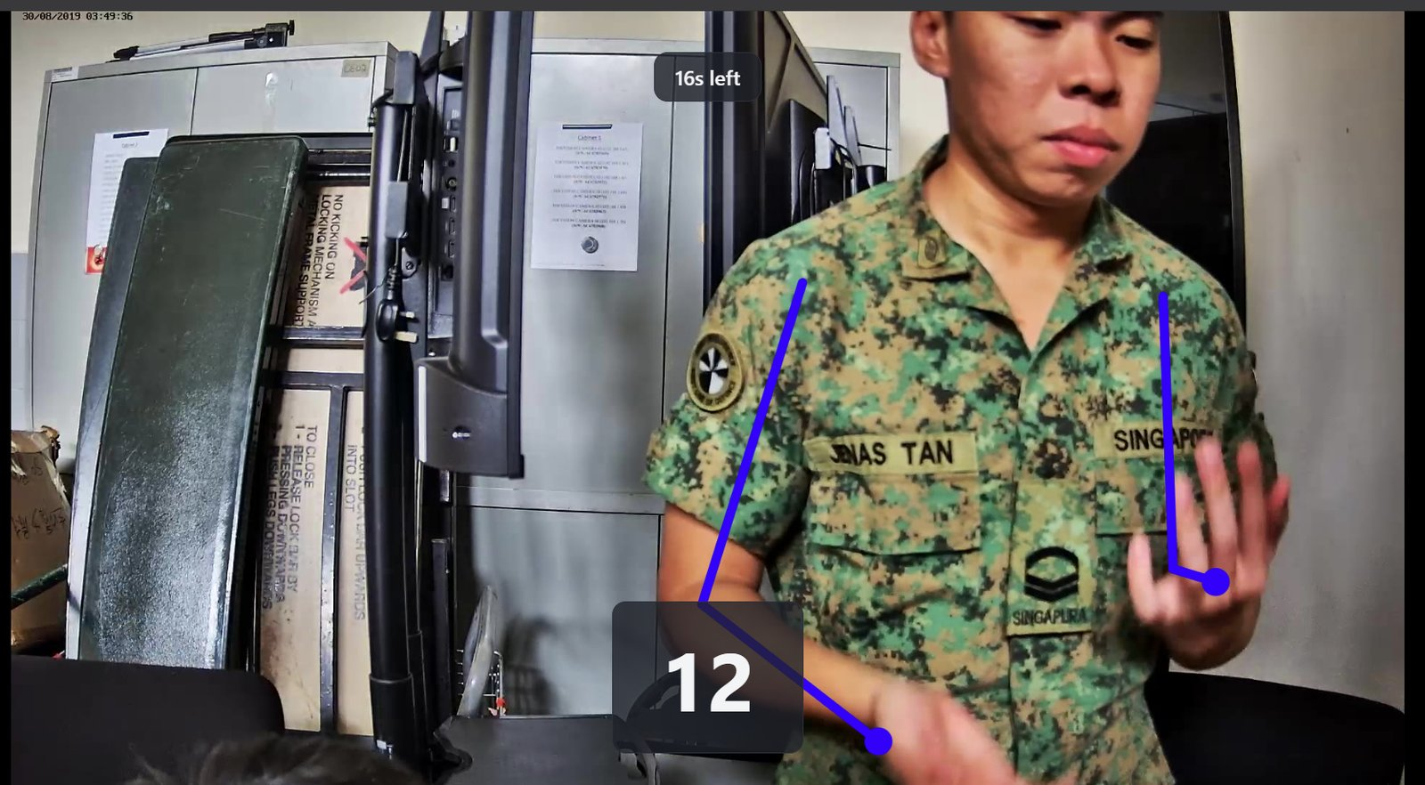

Results Screen
When the time is up, the results screen appears.
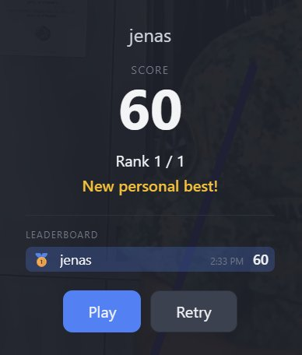
It shows your name, your Score, and your Rank (for example "Rank 2 / 14").
Below that you'll see one of these:
- New personal best!
- Your best: N. If you didn't beat your earlier score, the old one stays on the board.
The top-10 list shows medals for the top three, with your own row highlighted.
Two buttons:
- Play, or PageUp: a new round for a new player. You'll be asked for a name again.
- Retry, or press R: another round for the same player, with no new name needed.
The start screen is shown again, with the leaderboard, until the next person clicks Start.

Editing the Leaderboard (Staff Only)
- Press S, scroll to the 67 Mode section, and click Edit Leaderboard…
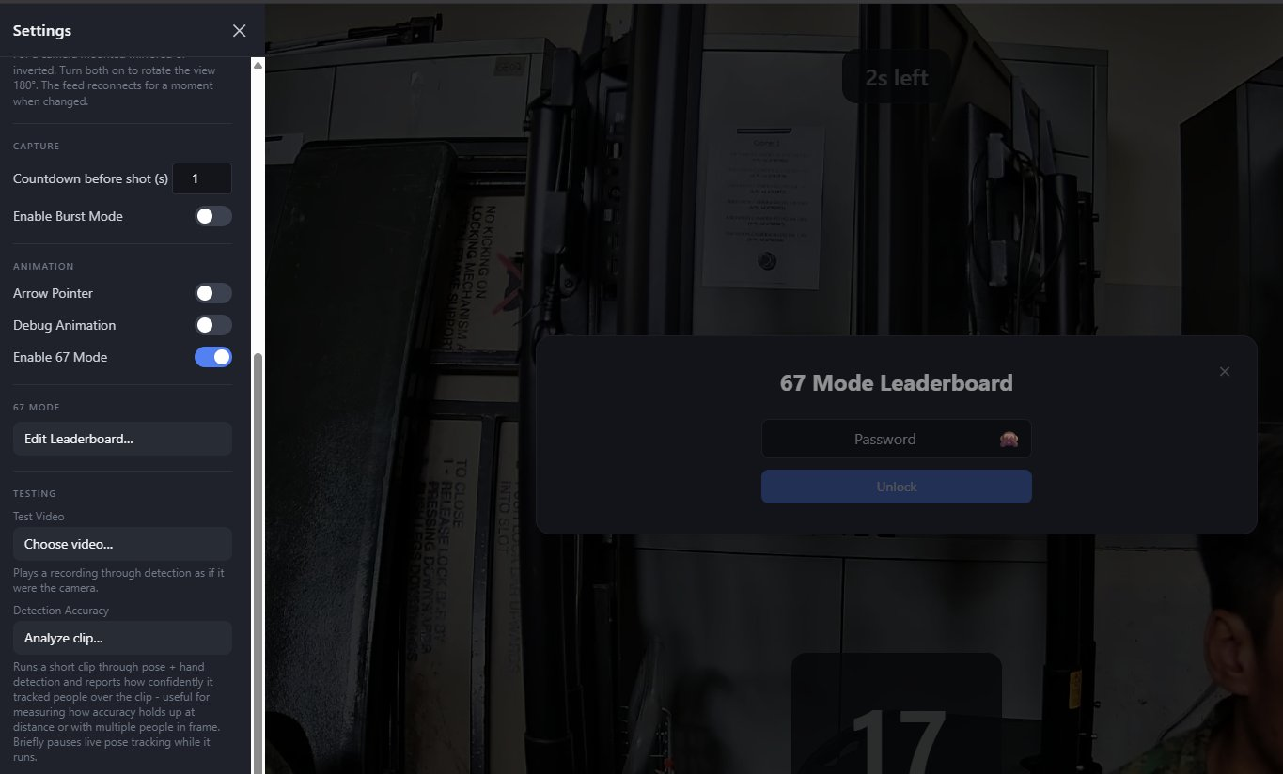
- Enter the password and click Unlock. The password is password123.
- You can then:
  - Change a name or score, or delete one entry with the red ×.
  - Click + Add entry.
  - Click Save changes to keep your edits.
  - Click Clear leaderboard, then Tap again to clear everything within 3 seconds, to wipe all scores.
Changes appear on the booth screen straight away.
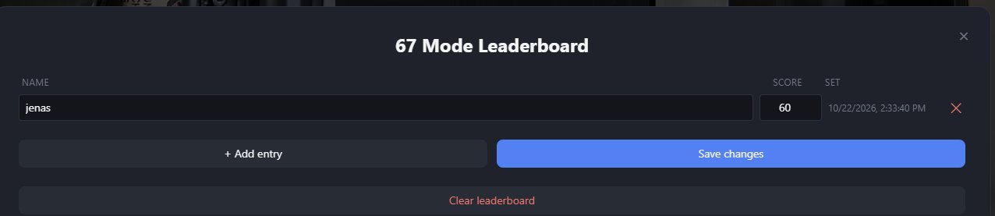

Using the Testing Tools
The Testing section lets you check how well the booth works without anyone standing in front of the camera. You use a pre-recorded video instead. There are two tools. It's meant for staff and developers, not for guests.

What Each Tool Is For
- Test Video: plays a recording as if it were the live camera. The characters appear on the people in the video, just like on a real camera. You use it to see whether a character shows up and behaves properly.
- Detection Accuracy: you give it a short video and it gives back a score card of how well the booth could see the people in it. You use it to find out whether it still works when people are far away or in a group.

Tool 1: Test Video (play a recording as the camera)
- Under Test Video, click Choose video…
- Pick the video file from your computer. It says "Checking…" for a moment. If the video is new, it's copied across first, which can take a little while for a big file.
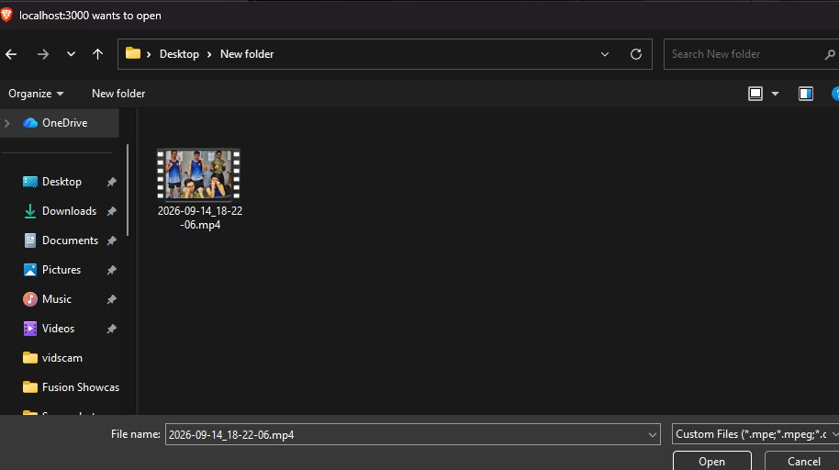
- The booth now shows the video instead of the camera, and it plays on a loop. A line says "Replaying [name] on a loop".
- Watch it as if it were live. Characters appear on the people in the video. You can also change characters and take photos as usual.
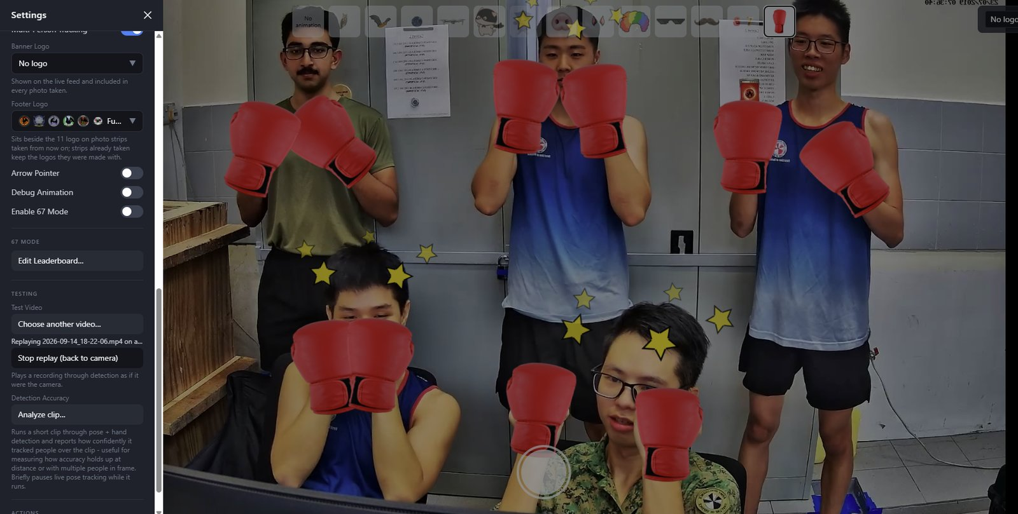
- When you're done, click Stop replay (back to camera). The booth goes back to the camera it was using before.
- To try a different video, click Choose another video…
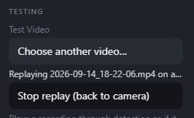
- If a red message says "Failed: …", the file couldn't be loaded. Try again, or try another video.

Tool 2: Detection Accuracy (get a score card)
- Under Detection Accuracy, click Analyze clip…
- Pick a short video. Short is best, since big files take a long time.
- The button shows the progress. Wait for it to finish.
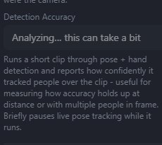
- While it runs, live tracking is paused, so don't use this while a guest is using the booth.
- A results box appears with a small graph and some numbers:
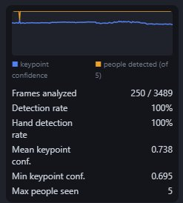

What it says | What it means
Frames analysed | How many pictures from the video were checked
Detection rate | How often it spotted the people. Higher is better.
Hand detection rate | Same for hands, as hands are harder to see.
Mean keypoint conf. | Its least sure moment
Max people seen | The most people it found in the picture at once

- In the graph, the blue line is how sure it was and the orange line is how many people it found. A dip means it struggled at that moment in the video.
- A failed message means it couldn't analyse the clip. Try again, or use a different file.

When to Use Each Tool
- For example, if the owl does not appear properly, you can use the Test Video feature.
- If you want to test if the video feed can see people 5 metres away, use the Detection Accuracy feature, and compare the results between videos.
Note: The testing tools are best left to staff who have some technical background, such as experience with video files, app settings and troubleshooting. If you are not confident using them, it is better to leave them alone. For a normal event, you do not need them at all.

7. Basic Troubleshooting

Make sure everything is running
- Open Docker Desktop and wait until it says it is running.
- Under Containers, ns-photobooth-main should show three items (frontend, backend, gallery), each with a green circle. A grey or red one means the process has stopped.

The page is blank, or there is no video feed
- The backend may still be starting. It takes a while to load its models, and the first start also downloads around 2.5 GB of hand-detection files. The page stays blank until it's ready.
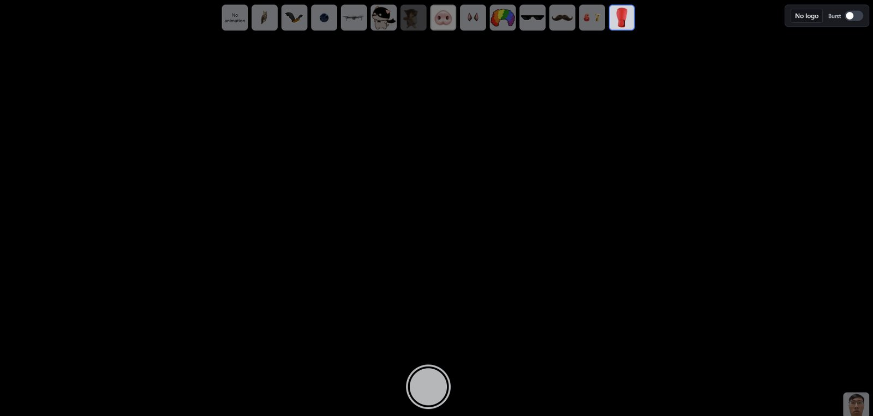
- If the page or the video feed takes a long time to appear, refresh the page once the backend is ready.

Port already in use
If Docker shows an error like the one below when you start the photobooth:
Cannot start Docker Compose application. Reason: compose [start] exit status 1. Container ns-photobooth-main-gallery-1 Starting Container ns-photobooth-main-backend-1 Starting Container ns-photobooth-main-backend-1 Started Error response from daemon: ports are not available: exposing port TCP 0.0.0.0:5173 -> 127.0.0.1:0: listen tcp 0.0.0.0:5173: bind: Only one usage of each socket address (protocol/network address/port) is normally permitted.
This means something else is already using one of the photobooth's ports: 3000 (booth), 5173 (gallery), 8081 or 9091 (backend). The usual cause is a second copy of the photobooth running, for example one started with python app.py.
Stop the other copy, or run “docker compose down” in the terminal and start the photobooth again.
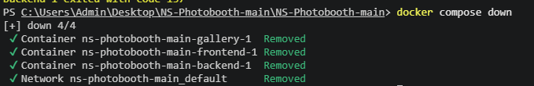

Webcam or custom camera is not found
- A USB or custom camera is accessed through the browser, not by the photobooth program itself. Check the browser's camera permission and make sure the right camera is selected (see the USB/custom camera setup).
- Close any other app that is using the camera, such as Zoom, Teams or the Windows Camera app.

Photos are not uploading, or there is no QR code
Press S to open Settings. Check that Disable Online Features is turned off and that a valid ImgBB API Key has been entered.
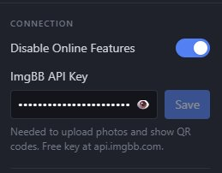

The RTSP/Hikvision camera shows nothing
Check that the camera is powered on and connected to the same network, and that you picked the right camera address on the first screen.
To check whether the computer can reach the camera, open Command Prompt (search for cmd in the Start menu), then type ping followed by the camera's IP address and press Enter. The IP address is written on the bottom of the camera.
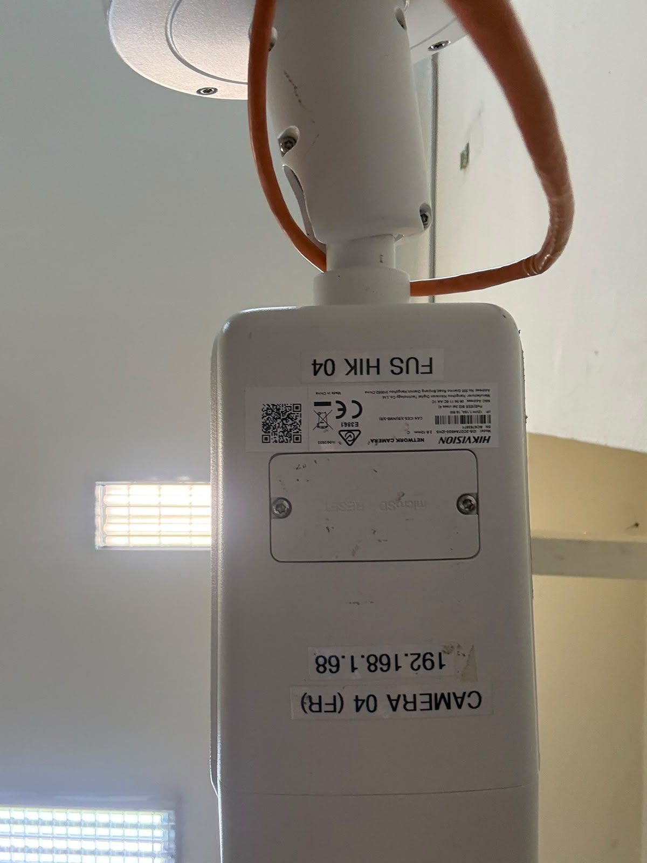
- If it says Reply from IP: bytes=32 time<1ms TTL=64, the computer can reach the camera.
- If it says Destination host unreachable or Request timed out, the computer cannot reach the camera. Check the network cables and the network switch, and make sure the camera is powered on.
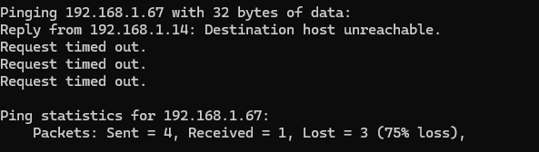

Gallery won’t connect
- Check that both PCs are plugged into the network switch with LAN cables, and that neither cable is in the UPLINK port.
- Make sure that you entered the photobooth PC's IPv4 address on the second PC, not localhost. To find it, run ipconfig on the photobooth PC (see the gallery setup).
- Check that the photobooth is running on the photobooth PC. In Docker Desktop, all three containers should show a green circle.
- To test the connection, open Command Prompt on the second PC and type ping followed by the photobooth PC's IP address (. If it says Request timed out or Destination host unreachable, the two PCs cannot reach each other, so check the cables and the switch again.

When nothing else works
- To fully reset the photobooth, type “docker compose down” in the terminal.
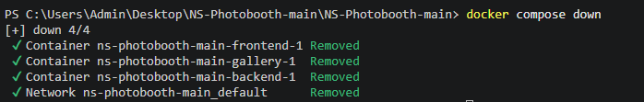
- Then rebuild it by typing “docker compose build”.
- Finally, type “docker compose up” to start the photobooth again.
